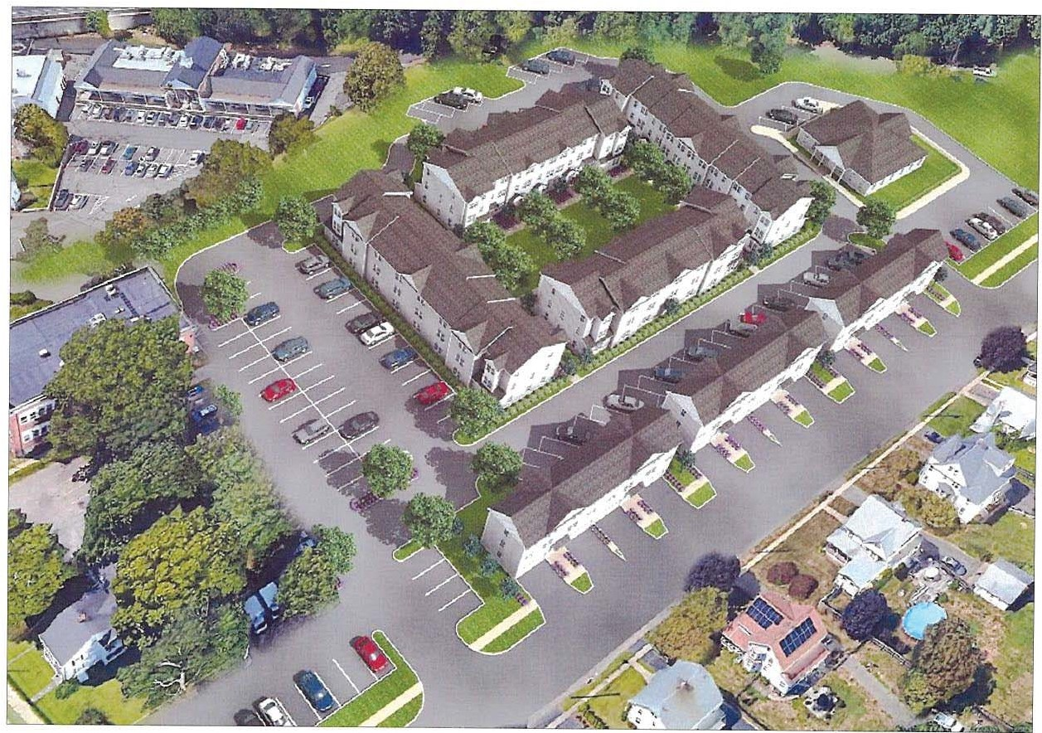

CENTER VILLAGE

TRANSIT ORIENTED HOUSING
EAST BROADWAY & SUTTON STREET, STRATFORD, CT

GUEDES ASSOCIATES, INC.

'lB'I
G

Designers , Architects & Project Managers 1425 Noble Avenue, Bpt., CT. 06610
Tel. 203-367-5180 Fax. 203-367-4961

P.tfIMROSE
C O M P A N I E S
BY, JOHN N. GUEDES

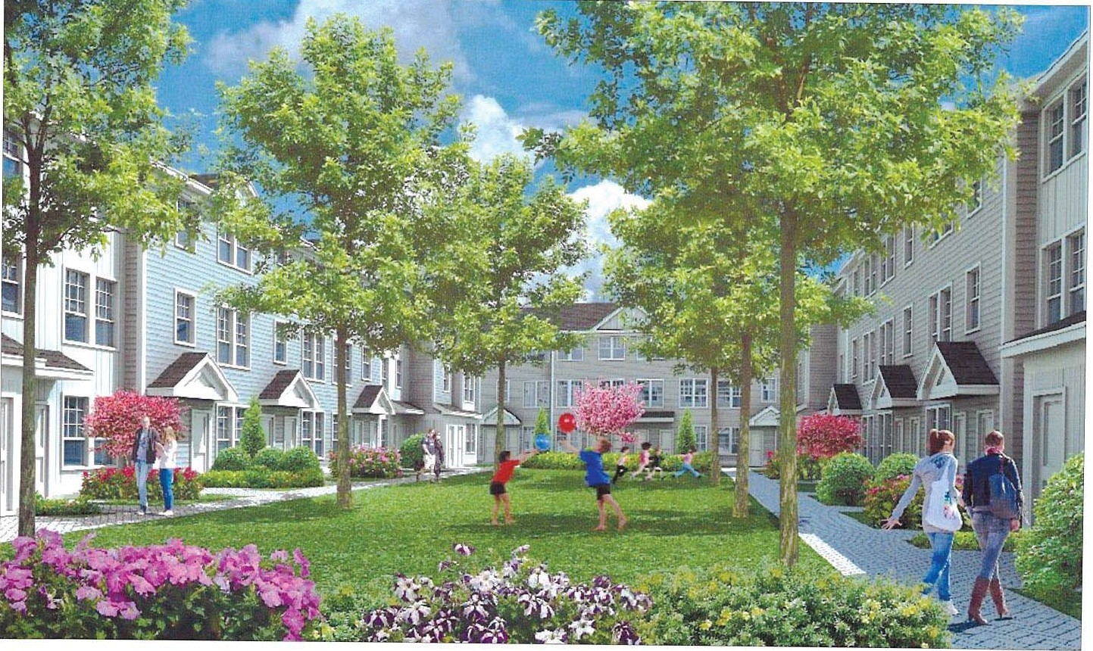

CENTER VILLAGE

TRANSIT ORIENTED HOUSING
EAST BROADWAY & SUTTON STREET, STRATFORD, CT
mclCm
G

GU n t 1q eNC.
1425 Noble Avenue, Bpt., CT. 08610
Tel. 203--367-6180 Fax. -4961
PRIMROSE
COMPANIES BY, JOHN N. GUEDES

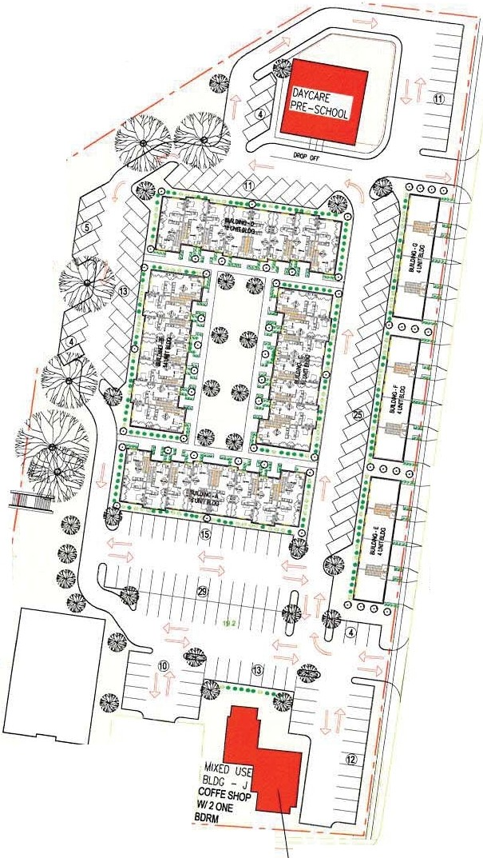
,_
6 "-"'<
·,;·\: . '
· :, ·
1. , '1.
,

, /
/
/1/"' I
I
I

I

I

.... (\I (') q' It) (0
SUOISIA8J

"""(
0
Z .,
- ciio
C/)- g,i5i i£
w j ;!
I- t
<(·g- , tsl
00
(.J) g £
.,s.;-
Cl) "' '!; ;;;
<( ;
Cwl) -8g
.;ZN
0w -., -
C:U)_:
::J 0
a:.
C)
@,..
lu [
, ll i
c1> o
i
,
PRIMROSE "li i
i
io
^{l}f^{i}fiiE"
w
C O M P A N I E S
11:==-f:...=.-. -·---:.:::,..:.,:.._:_ 11
s L-1
;;;

z
I
@
:::,
{/)
I
I

I
RESIDENTIAL

I
I
I

I
□
-- j

RfOOEH1W.UNm; •74
TWOBORM- 34 OIEBIJRII - IS Sl\JOIO UNm- 30

BIDGS A&D -8 51\IOOU TWOBIJRII BIDGS B &C- 7S1\IOO &7 TWOBIJRII BUJGSe-.F &G• 4 EBORMW/OEN BlDG H
-
BlDG J • 2 E BDRM

COMMERCIAL
DAYC>IUa-PAESCHOOI. • 8.791SF

------- - - - - -
SITE LAYOUT PLAN
SCALE·1' a 50'

EAST BROADWAY EXISTINGBUILDNI G
TOBECONVERTED
COffEESIO> - 2,lOOSF

TOTAL • 9,'86Sf

PNOONG • 1511SPACES

BASE&CONCEPTDESIGNBY: T\JCKERCW.SC.ARCITECI l8/,CN£MYt111ITf<RAC< STRAlfOAD, CT,011115

·t.{,:·:.·i
, ...-. _ e- -·,,
, 1 l£11' ,,.,
.. ,..-l\ • e

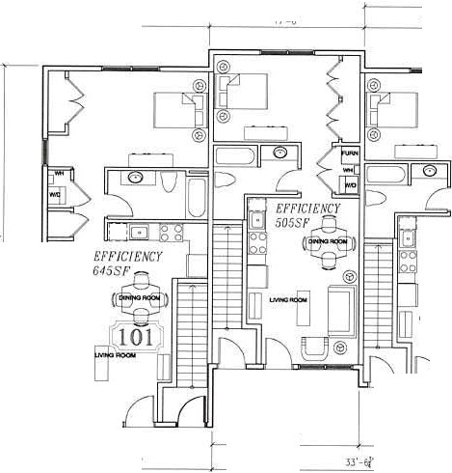
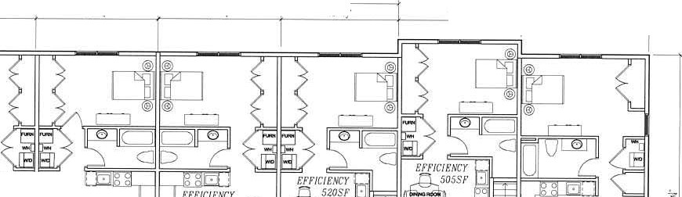
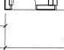
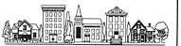
1.5g•- -
0
Z.,
⁻ (/)-gc§i,>o §
w j ,:.
<- (- e <.)8
I- u..:
o a. a:.-(\.t
0
cd
(/) "'"
en
t, =>o
Q) C a:,
_,,.. Ee<tr:.
....... .,: .!
(/) . {l <'I
W z
0w .Q)
i!l­
:::,0
a:.
CD

0 7'- 11''
IB ' - .lj" ..!I:£ 16'- 7f 17'-</' 17'-31" H1'-7f 17'-6 ' .!.!:.!
"' ., ...
SUOISll\8J
- "' "'

Eff/Cl t'NCr r! ,
!
•"" i{!r"" ... "":8. ~ . '-f i::::-I:I Cl:-i l NCY
_{[J} m-w5 n!OJ- t±l :fA □
@ @
-tt
DJ m- t]
DJ

®Q .
J h h

16' -.j"
1 1' :.'ll: 11'-•t l l' - J/" I
,r-oJ· 16'-Gj'

1_g_:_ Jf -a· JY-6/" 18-' ro·
I J9'• 5j'
FIRST FLOOR PLAN
SCALE' 3 / 16 " = 1' - 0 "
li!li
,. ig

::
"<<a
I
....
ur►

H
PRIMROSE" 1•' IU>0
l'!Ii

!
ii:
'<!:'

11--O=-:: -e:=-.A=='=,-E-- I A-1

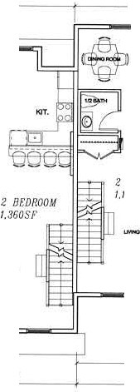
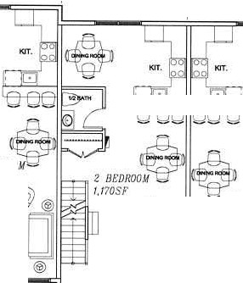
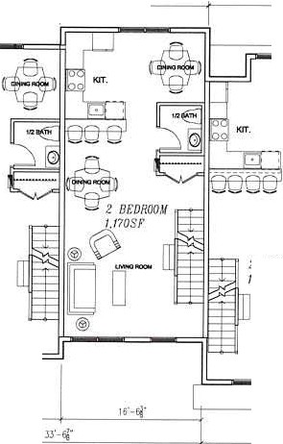
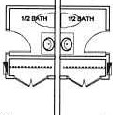
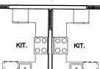
;'_:y.; 0.
0
(wJ) (D
-Z _ ,,,
­
;!
o £C
<( 1 o gi
f- - ,-:
O "' i
Cl) g
(J) .g in
<(
-fi < r-'.­
r.n 2
< lll
W a, •
, Z N
eCJ
:::> 0
ow .Q­l
;

.itt_-q")
,·
;.-t-

1J9' - s.t"

61' -1 !!1_"
.)
,,._, -

IS '-;j" .!L:£ 1'6-:f 17'-J,i" 16'-?f 17'-ft ,a·- r

- "' M "' "' "'

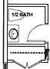
:r BE:D//00
♦ ♦I I

1n ·1I

,.---·-
SUOJSJl\ 6 J

'70SF
0
Bl' DROOM
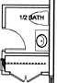
-□ - ,2 IJF.01/00 M , llt' DR l,170 SF
A
□-
@ V
-□
'.JI@
20ss1· .205SF A
A
2 Bt'DR00M
O] f⁶ii -- --
[O
[]□-
:f
l .360S!' A

@ lLI D ll±ll=EII D ® O]
®O
TI
'.JIO@]
'.JI@)
= -- @ @ - -== - =
@) @

,a·- r
1'6-2[ 11'-.!'/·
Jl'-Ej'
, r . , P·.

.l•·-·s
1)9' - ai'

17' - Jr," 1 1'-oj"

18' · 9 '

SECOND FLOOR PLAN

SCALE 3 / 16 " = .1 - 0"
a
- i.. z 1l

PR IMROS E
1 ; F
I
I

1 1--'.'.g-.-.:-
-·i:--?I@i-i

A-2

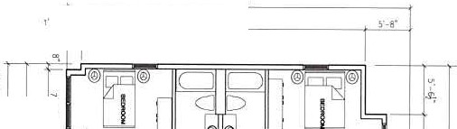
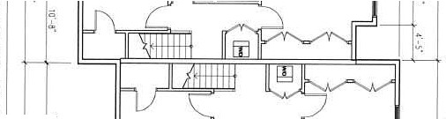
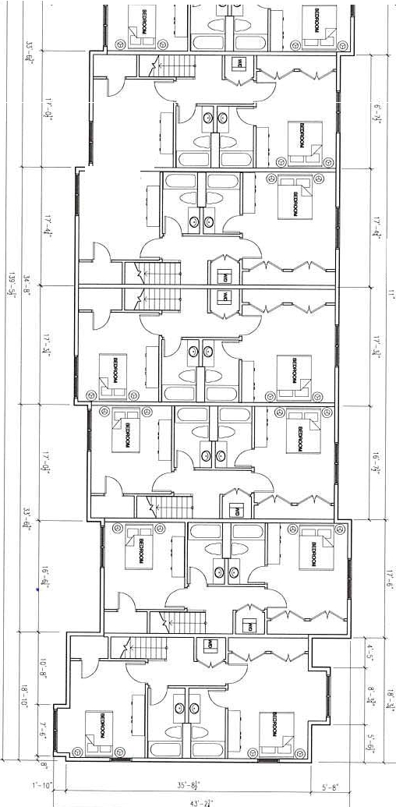
<J'- 2l"
-I
:::0
0
r'"T1
"\

"'I
;:
,-
,.
o,
,-
:::0
"'Cl

z
ai
';"'
"l
/4
.
I
®rn®
® ®
i
1
-
"';
-";
I
!s = = o
S TRATFO D. Cl

ll<!RO FLOORPLAN

VJ
I
i:--.
t>i

0)
0
11 0
-
I
a

-

f.c
d:
:.=.;
.;,.,,;= :: +.,c,.c:.,;J,
1, 7 1
o:o,,: :::....--,
NOr e.o
;:
JNOVEDES
1
2
0 3
: "' 4
iv 5
6

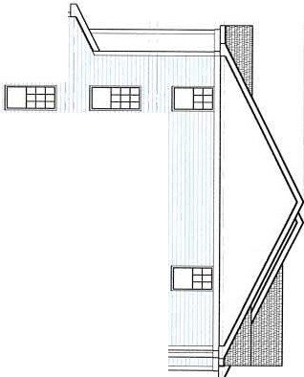
Dml [Jffl]
l[§!l] [[Jffl

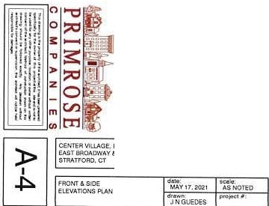
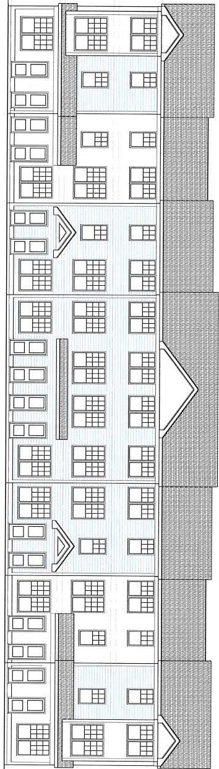
I
STRATFORD, CT
a: :::= :EO
:!!2
0 3
:(/) 4
G GU D s n ! !!J l .!N.C.
142 5 N obl e Av e n u e , Bpi., CT. 06610
Tel. 203-367-5180 Fax. 203-36, 74961
ii, 5
'- s

Cl)-:JJ
-Ien
n o m m rm
-I

Dffll coo
Dffll IClaJ
El El El
El] El P3

0
z

IOil3J I
DE§]
El EB

GUD : s.-n;,

1
!!!; ;.!N.C. 2
5
6
·"' 4
OJ

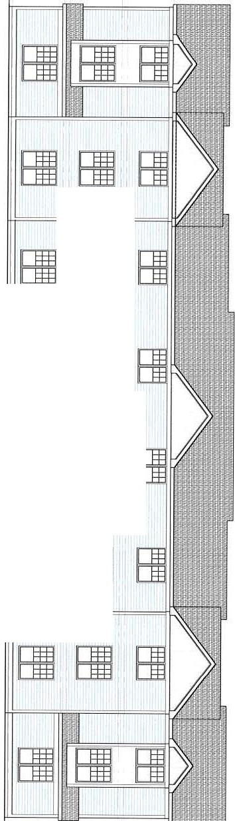
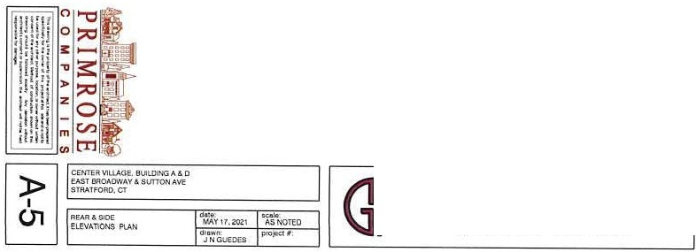
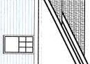
14 25 Noble Avenue, 8p1.. CT, 06610
T,el 203-367-5180 Fax. 203·367-4961

- :7;'.'.
"J® g·
·:;p.

- N |  | "'" |  | "',,,
SU |  | O!S!l |  | l8 J

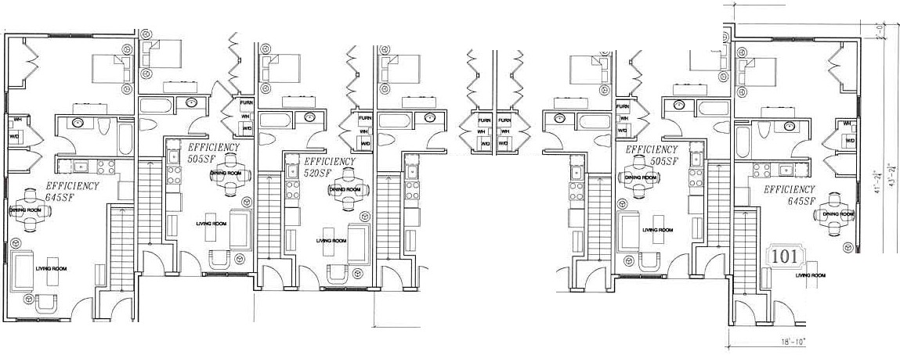
FIRST FLOOR PLAN
rrt -.,:r
If- 1 \
I
H '
- 7'" ?
"'
Jb
1r-1t

7 ii-
• ,r, • -oj• 1.
r, .oJ·
7 11 '

.,h
, r - 6·
[
I

1-
!

J I
EFFICIENCY t'l'FIC/ ENCY
- II 520 Sv 20SF

Qt
\1'-i
rs· 10·
16- GJ·
,r -1·1
5 1'- llJ·
122'-•/"
1r-2r
□
16'-
-
0z
CJ) 0>- -
- _;o
w :U:. .
0 o0 &
0
-·o
t;ij
,8N
Q_ 0. '

C/) g
<J:: <
(J)
C/) ,, ru-
w ;
0 . "ijj
W 16!
:) 0
SCALE 3 / 16" = 1 ' - 0"

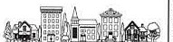
1 1! 1
,

!Ji i

lj!
ii

o,
H
•
i
IS •

PRIMROSE
-ir=.--.-.:.7.·.-·-·..·..---:··--=.·•··:-.---.·--=:-.:.·-.::-.:;[AE-1D

•- Ii) N;,
,, _:=.;::::
, . ,,..,,.;·.,
,.,.
.
-*

1 8 ' -l!'
5.• ,. l
111 • •1'

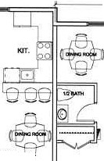
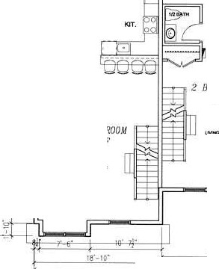
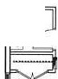
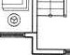
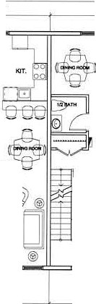
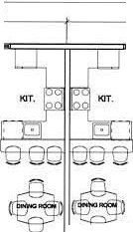
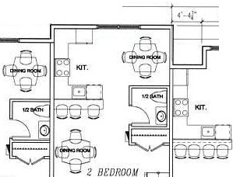
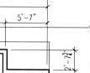
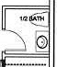
.!!::£ )l)'-1oj"
f -•l"
i
8' -l /'

18"-Jj '

1
',:' ♦
17•.,;·

17'
17'-0!'
a·-ir

- (\I M '<t" IO CO
SUOJSJ/\8 J

,!f,
I I
1"1 1H 12
I I I-
-ifio_
W ::i ""
wi
-gt
I-

I

s
:li
C::
'EDROOM =
0 1,170 SF
□

U 70SF
<o__

i"I
<( /j' "N
- o .d.,:IcIli.x
0 C <D
" "' -
0

76'
1,170 Sf
BEDROOM-=
•,Jz BEDROOM
1,170SF
16°':;l
C/) o

I rl
DI Il -
[O-
@
□
D
2 BEDROOM
360SF
®
[O
®
□--
·- . TI 0
I 2 B OROQI
i T'I 20,SF
i jJ @

- t]
@
®◊ -
2 BEDROOM
,t 3 60SF
O@
-□
C/) :E .'( '9

U) i
<C t
®
w0 .&...a..i.
w -
::)
CJ

.!!::.:'J_"
□
®

1r - ,r
□
I ll -2j•
a::.

10· 6r 51'-aJ" 1''- 6j"

SECOND FLOOR PLAN
SCALE 3 / 16 '' = 1' - 0 "
112'--'t°

PRIMROSE
Ji:.-:

.m,,<.
9
s
.m.
"
!e
u3

l<l/i
..:,m@
1
; ia
I .i
a!;

0

C O M P A N I E S §J
==:::"""'::.:.::-_·- I A-2

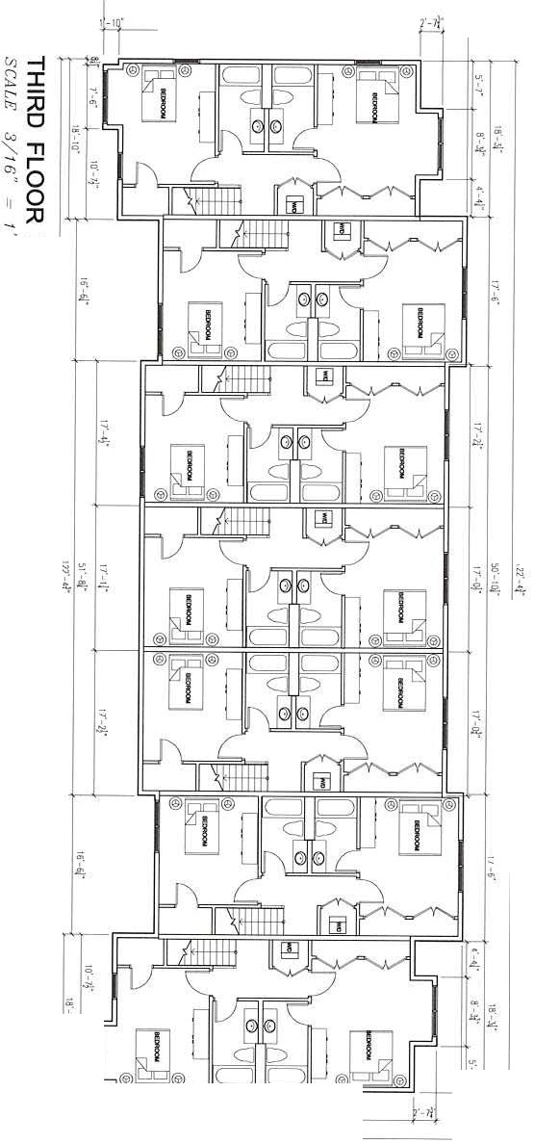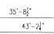
00
I
.
a
GU o:S n A ch esq
, T •• NC.
1425 Not>le Avenue, Bpt , CT. 06610
Tel. 203-367-5180 Fax. 203-367-4961
IMADF\O. Ofl llVoH 1 y-=" ·"' "1
- •NOW:oo-
=0
•
O E NTl:RV.'u.AOIE I UilD INCIB&.C EASlBROADWAY' &SVTT0.".4AVf STAAH'-OAO, CT
_ _ _ _ i:,•-ij• -i-...,,
oI r1J
' )>
z
::
c;_

'E
-.
,1-,4-

 | I
2  03 |  | -
"ii'4i
5
a l

S: ;· = ! c
S l RA'fFORD, CT
I
datw.: su 1- :
: : :
lcoc=}":-'·'-°''+•"<">ot'=;; ":D ---,
J N GUE OES

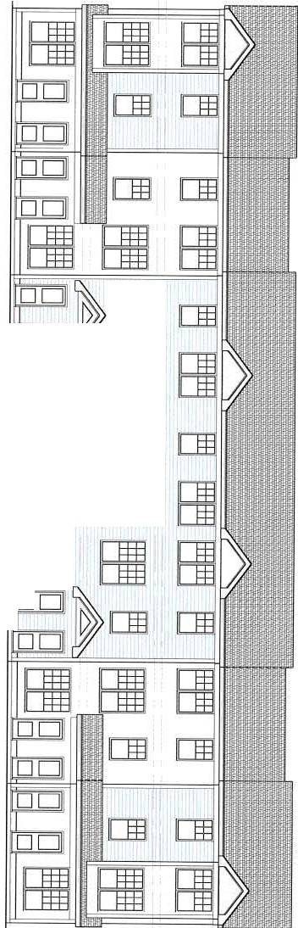
Cl) .,,
□
□□
□□
[fl]
El
i:m
El
J□_
El El
2
:a
n, O
c.i Z
::. -i
°'
II r m
- m
-i
0z

Cl)r
2m
n,

[fill]
-
en
II rag
r-m m
:::! [§If [[Jfflj
0z
[CJ!§ [lffi
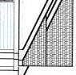

1
(I) 2
oC a-
:<I)4
iii5
... 8

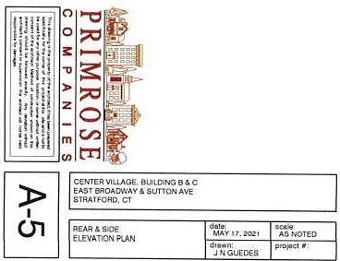
2
0 3
iii 5
6
:(/)4
1

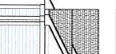
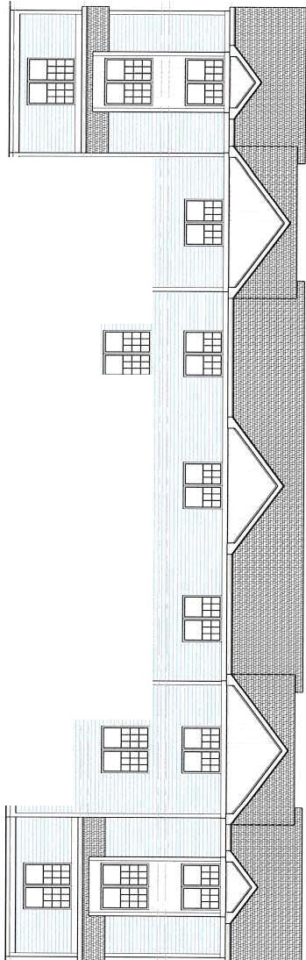
Cl) :0
Dffi [E ll
[COO
coo
[1ffi]
am
El El
El
El El
El rEI
El

-i
oi (/)
II 0
... m
m
r
m

-i
0
z

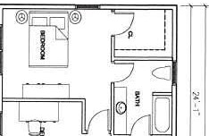
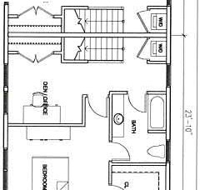
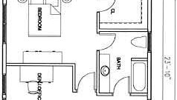
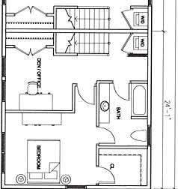
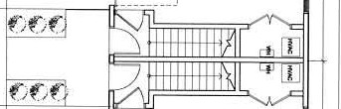
V)
I
-
i5
,,
i ( i f ) ( ,( i
--------i
(/J
Q :::a
c:--
-
'
C'J
,,
-l
en
:
''
g
I
')t
r
!'
'
_J
i
o ,
I
'
i
£
!"
o ,
'
•
'
' '' '
'''
'
'
'
g
I
';'
q
£
I
_ ·)(__·;_K- )l'·)(1
7J'. a
I
.i ( i ( )f' i ( i
( i f)
( )( i(
z
"'O
►
-l
Q :r:
c:-- :::a
t')
_ -;:,:,:.. ,r,
0
0
11 0
-. :::a
'►
6 "'O
z

V:
;;,

V) en
Q m
c:-- (')
t-.,0z

!@I

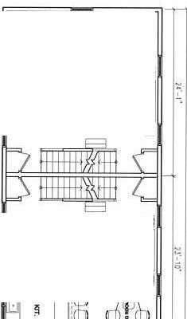
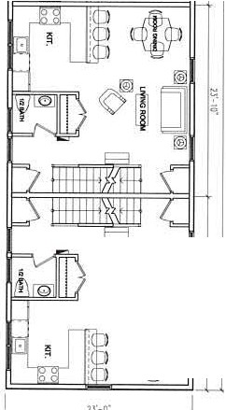
io,, O]
It 0 r 1@
-..0
:::a
-a

►z

[lj
I@] i

!@I
OJ

,-
q

'::
i5,

') l.'- 11"

(©) □

';'
a.

1§1
I r
C.ENTEA VILlAGE,BUILDING'S E. F AG E!ASTM OAOWA.Y& SUTTONAVE" SlRATFORO. CT
I
FLOORPW..S
1-.-:, :.:'=,,.'.-"a-='-1-.=,.';a;,;;,, ,;,,:'--I
JNGUEDES
d:JJ y t7, 2 02 , NOreo
•

1
2
0 3
:(/)4
6i5
6

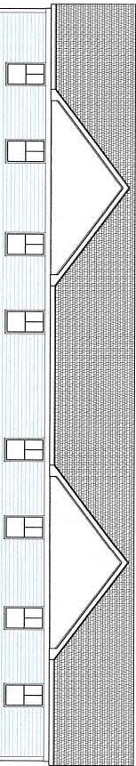
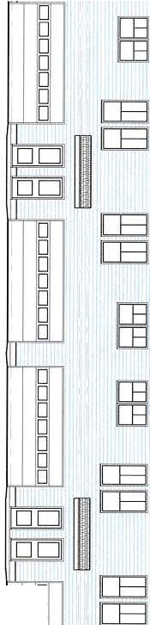
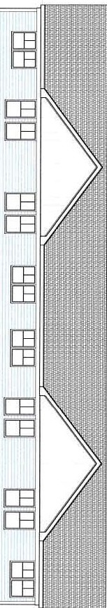
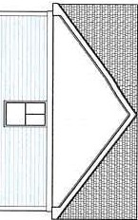
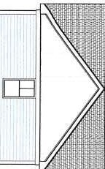
:D

CB lCBl

rn l[E
r--

.r.r.,. :D
m
.1.1..• <m
q
)>
-i
0z
rn CB
[E [Bl

ICB [E

[B [E

rn [ B

[Bl ICE

1[8] [E

[8 [E l

c,:, "Tl
:D
l..i..iOz
-i
.I.I.. ,m-
q,-m<

0z

□
□
□
D
D
1
2
0 3
:fl)4
5
8

CallE._ Yl lAGE -BU:LD1NGS E. F &G EAST O>.O'NAV& SUTTONAV£ STRATFORD. CT
G GDLJ

s n ?A ! l !: 1 e!sNC.

I
E LE\'ATIONP1..A r.1s 0 r Y,, . m , Ts16 oTED
1425 Noble ,Avenue B p t. , CT . 06610

17.,.-=., -;-:.==,..,, ,- -,
Tel. 203-367-5180 Fax. 203-367-4961

L-. _ _
, J_N G_UE_OES - - L- - - - - - - - - - - -

V) .,,
r
(')
::i:,::

G) (0
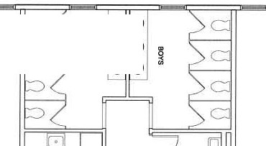
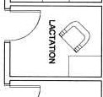
9 G) (0

t-; 0
G) (D

t"l::i 0
-... :::a

r -u
,r□----
I
---□-7,
I

II )> I
-... □z
I
1
I I
I I
C) I
I
'I □
I I
L'□_ _ _ _
I
I
□
1
I I I
I
I
□'I
I
I
(CJJ] I

'0-0-"

C ENTc.i:Vt I.ILAGE.DAYc eCENfER
EAST B O.ADW"Y & SUTIC AV'f;
STRATFORD, CT
I

2
0 3
FLOO R Pl.Ml
d 'J_ 17, 20:l'I • ;,s'll OT EI)
J N a ueoc.=.s
t-,c=,. ..=. - - -i-,,,,o,";_,"c,,t...,...-.-;
5i 5
6
:en 4
I

C Et-lTEAVILLAG E. OAYCARECENTER EAST BAOATh'VAV & WTTOOA.VE STllATFOA, O Ct
I
ElEVATiON PLA14
t!;,1, 7 201 1
OTED
1-,d,-,.-,.',""'---,- --+P-"';-Q, cc . -
J N GU EDES

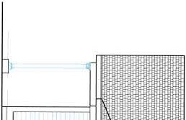
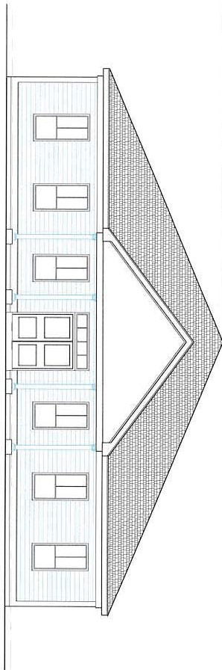
' fn "o':a
m
:::! '-Iz-i
0 • m
z
- r-
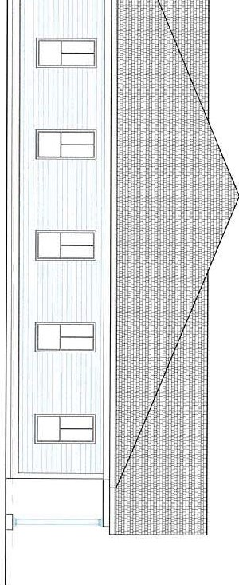
q
0z

I
2
03
_r.tJ 4
5, 5
6

