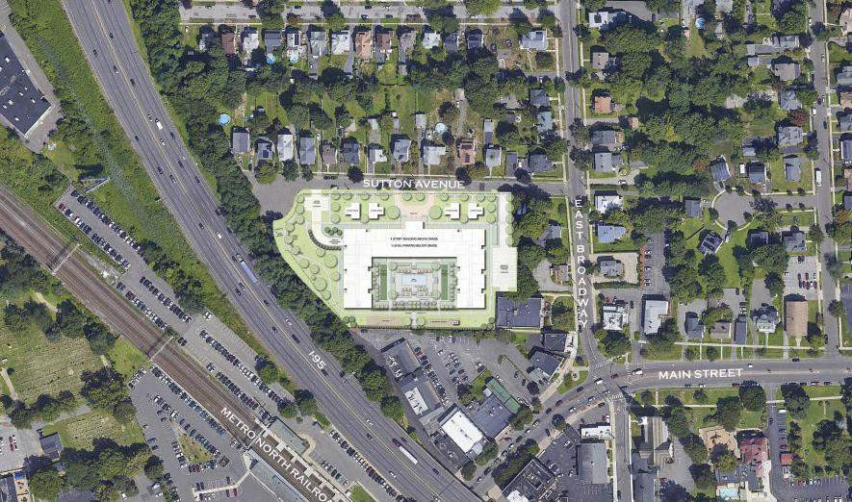

Sutton Place is designed to have a positive architectural impact on the surrounding neighborhood.

In this proposal Sutton Avenue is lined with four small homes that reinforce the single-family character of that street. The 4-story multifamily building is set back 80 feet from the street, has a traditional wrap around porch that further reduces the scale of that building, and provides a welcoming transitional space. 198 parking spaces are located below grade, both under the building and under a fully landscaped amenity courtyard for the residence. The area around the building is treated as a park providing green space for the community.

The architectural program consists of 21 studios, 96 one-bedroom units, 41 two-bedroom units and 4 single family homes, for a total of 162 units containing 211 beds. Parking is provided for the Board of Education generally at its present location. No curb cuts are proposed from East Broadway so as to not impact the adjoining historic buildings. While the entrance to the building is currently situated along Sutton Avenue, we are open to discussing other concepts.
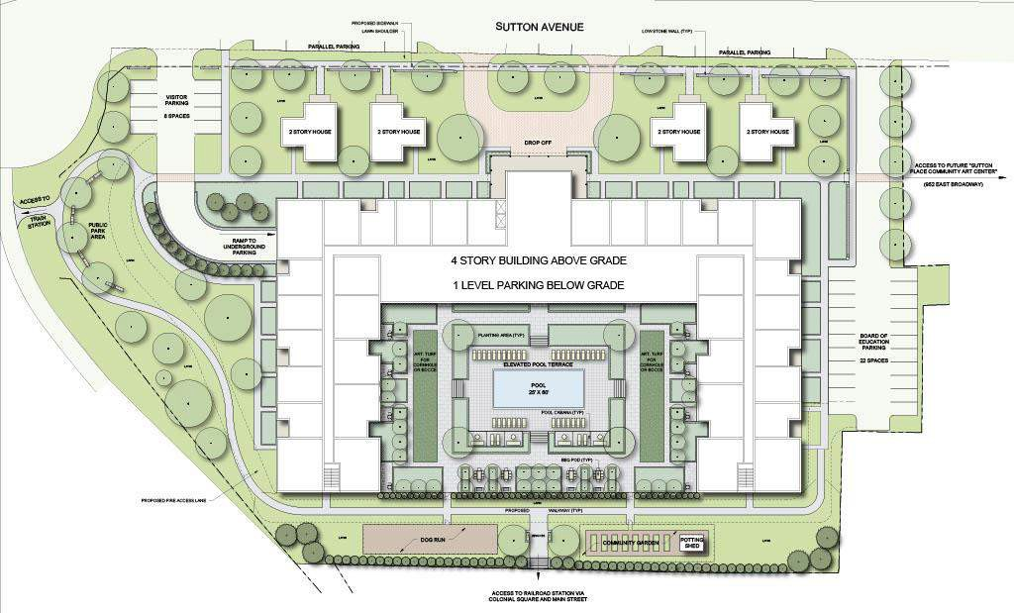

FPO
INSERT WITH SUTTON PLACE RENDERING

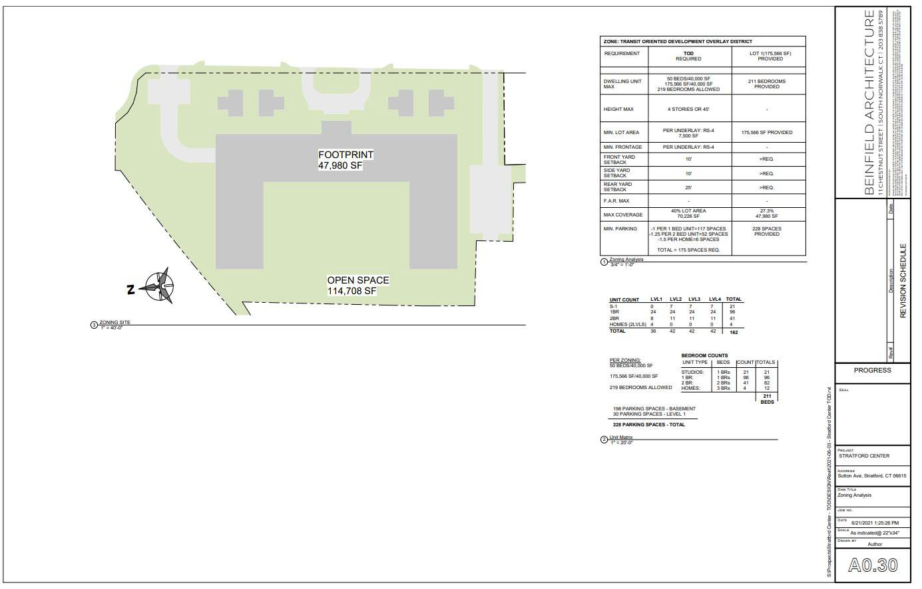

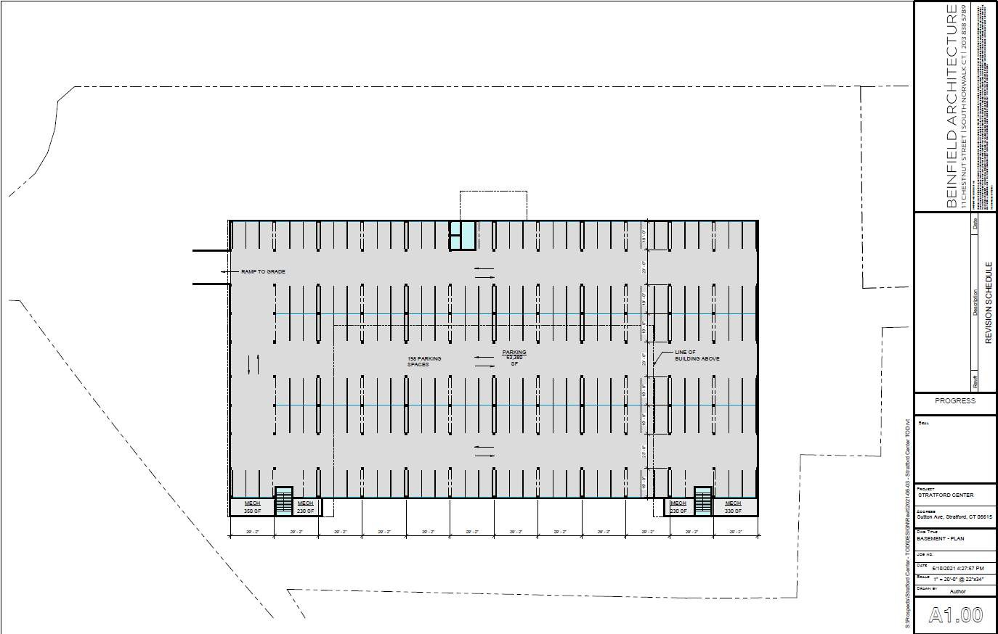

FPO
INSERT WITH SUTTON PLACE RENDERING
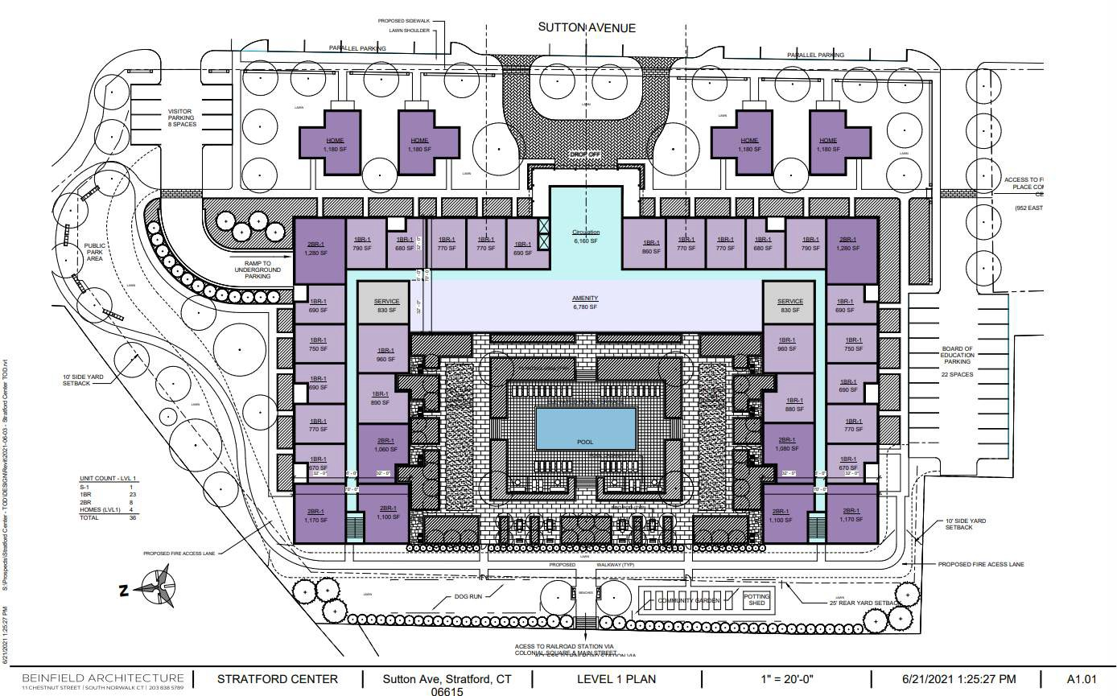

FPO
INSERT WITH SUTTON PLACE RENDERING
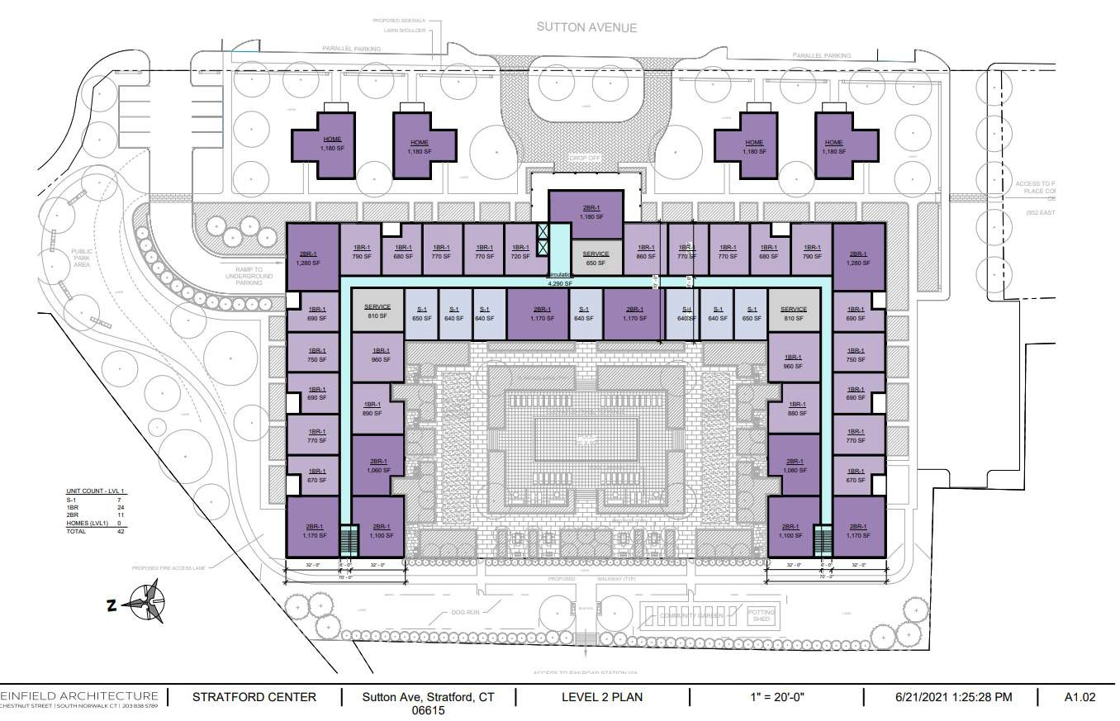

FPO
INSERT WITH SUTTON PLACE RENDERING
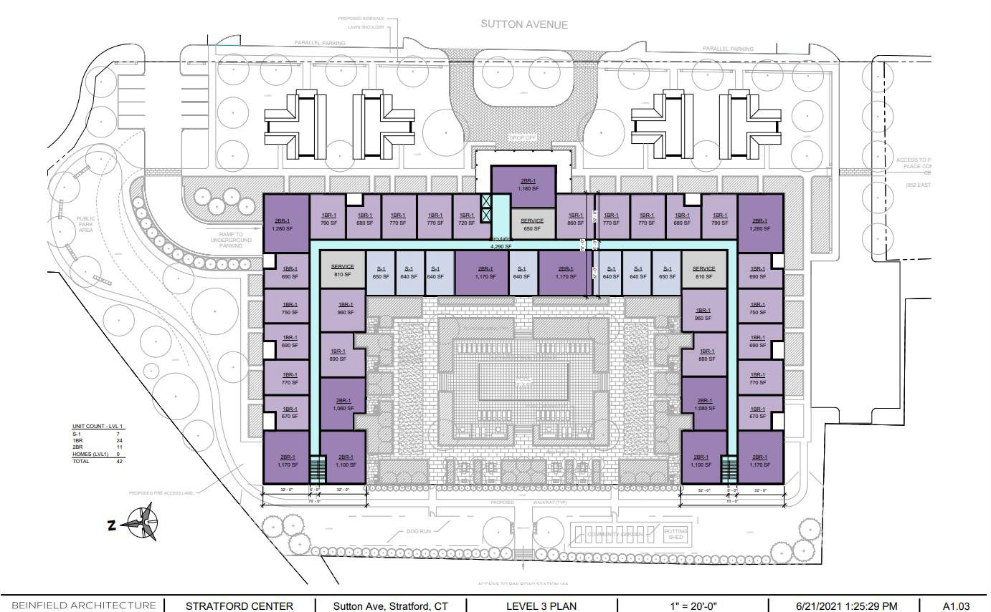

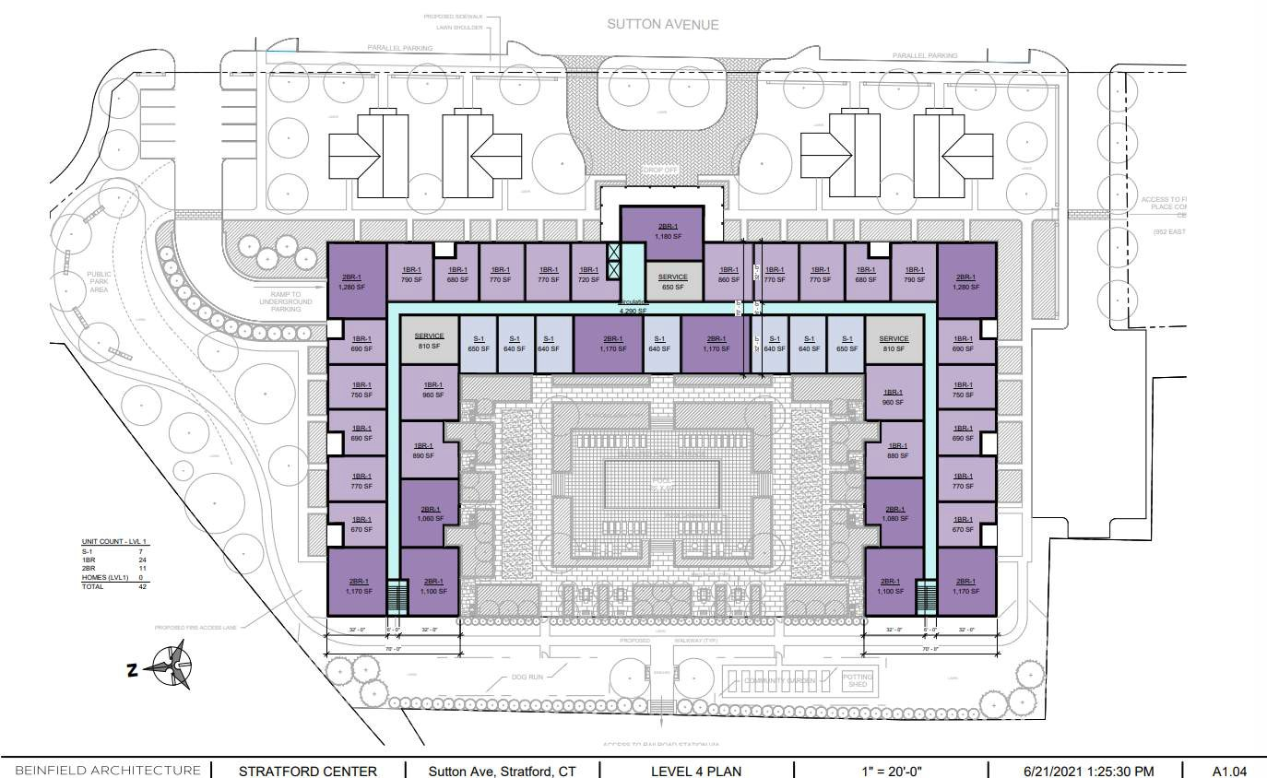

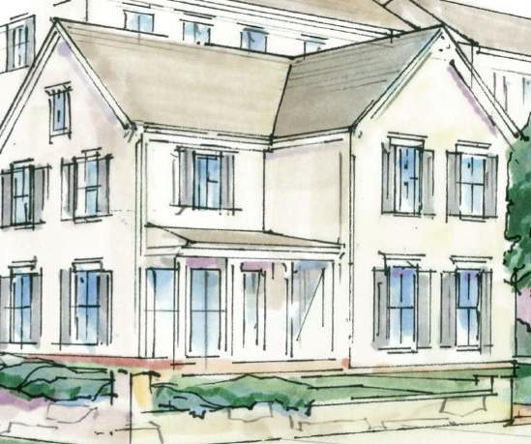
Our Design Mission:

To create classic project architecture to preserve Stratford’s cultural
identity

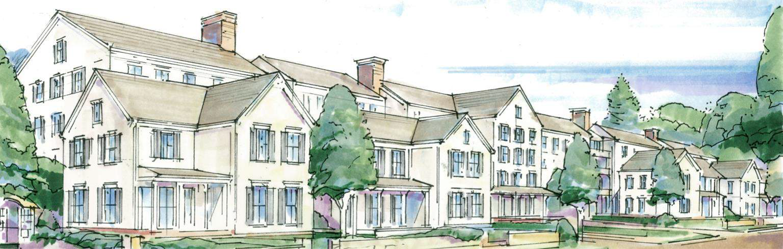

Classic New England Style Architecture
- Symmetry (inside and outside)
- Covered porches
- Clapboard, or shingle looking exterior
- Classic roof lines and pitches
- Chimney elements

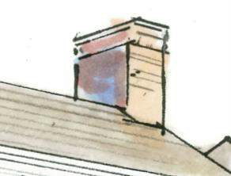

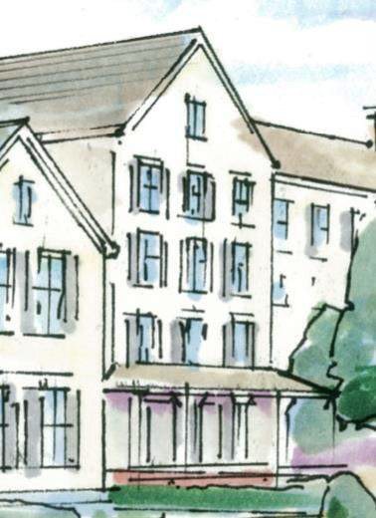

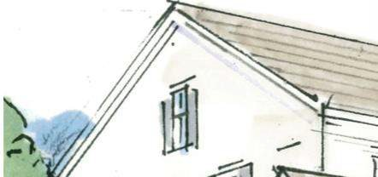
A Focus on Classic New England Architectural Elements & Design

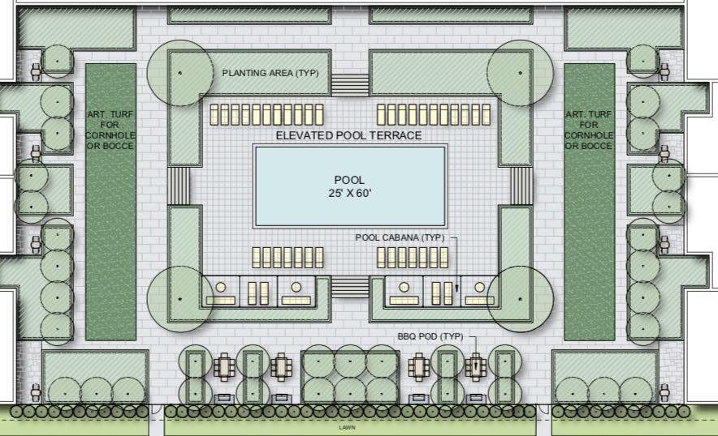

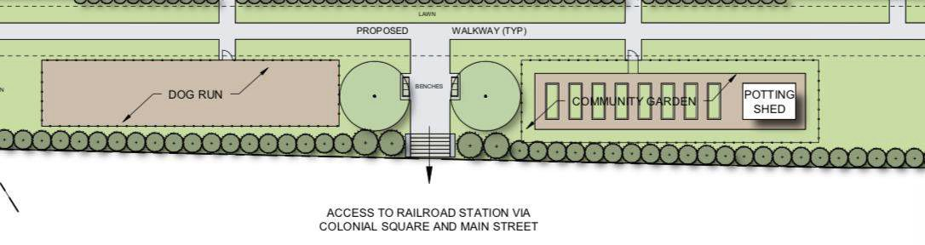
Benefits of Resident Dog Run

- Allows dogs to exercise and socialize safely
- Encourages responsible dog ownership
- Promotes dog owners a place to socialize and meet new residents
- Makes for a better community by promoting clean health and living

Benefits of Resident Community Garden

- Access to fresh foods for resident consumption
- Increase physical activity through garden maintenance activities
- Improve dietary habits through education
- Improve mental health and promote relaxation.

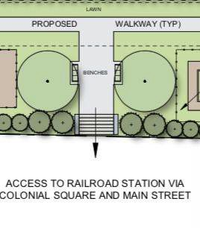

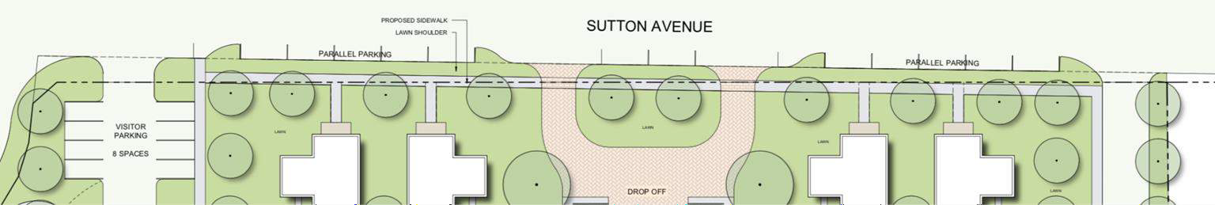
Proposed Streetscape Improvements on Sutton Avenue: Benefits for Neighborhood

- Sidewalk extension – Increase the usable sidewalk space for pedestrians and greening; Increased connectivity to Colonial Square and Main Street
- Potential crosswalk – Highlight pedestrian crossing areas for pedestrian safety;
- Underground utilities - Remove visible utility service wires and poles and install conduits underground to connect services to Sutton Place
- Road lighting– Improve and upgrade street lighting for safety and energy efficiency
- Bicycle and walking improvements – designated walking paths, public park to improve bicycle conditions and train connectivity
- Public art elements – Create a sense of place, interest, and neighborhood identity
- Site furnishings – Provide resting areas, benches, planters potential, trash receptacles; and
- Stormwater elements – Improve site drainage

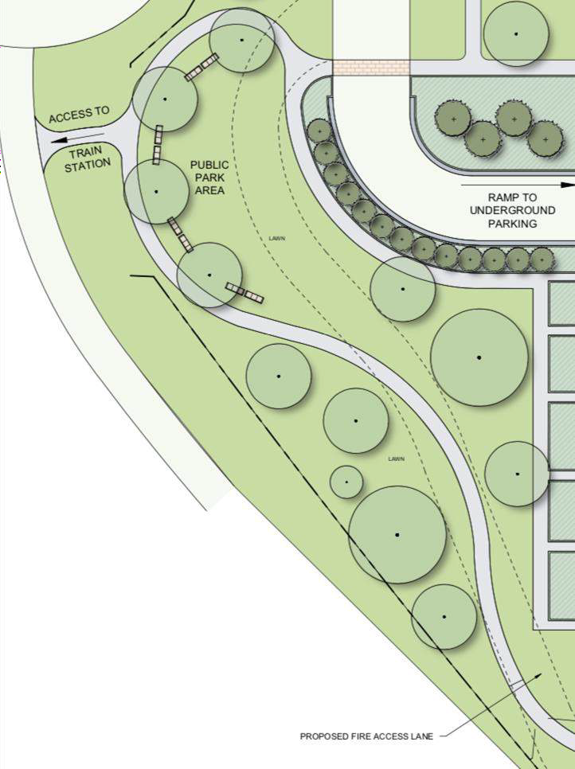
Sutton Place will have a designated park space for the neighborhood and community

Why is a public park a neighborhood benefit?

  - Promoting community wellness
  - Providing connection space
  - Encouraging activity in kids
  - Improving property values
  - Creating a safe gathering place
  - Better access and walking paths to train for easier connection

