DEVELOPMENT PLANS AND CONCEPTUAL DESIGN

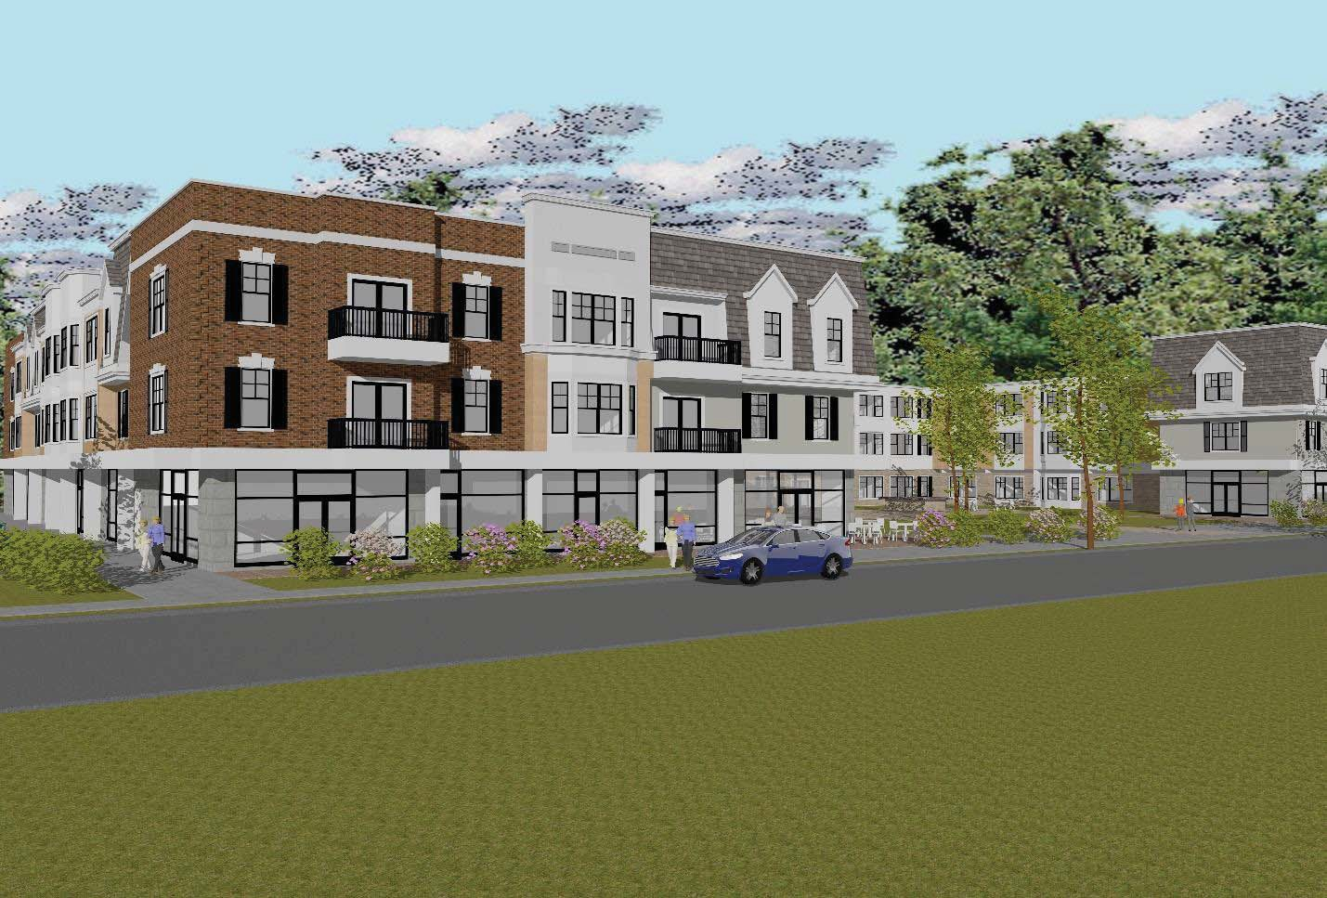
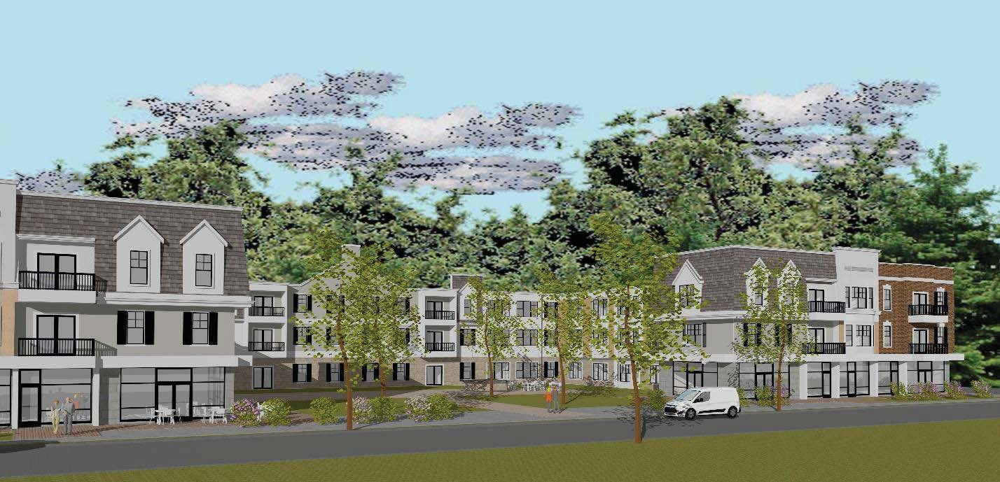

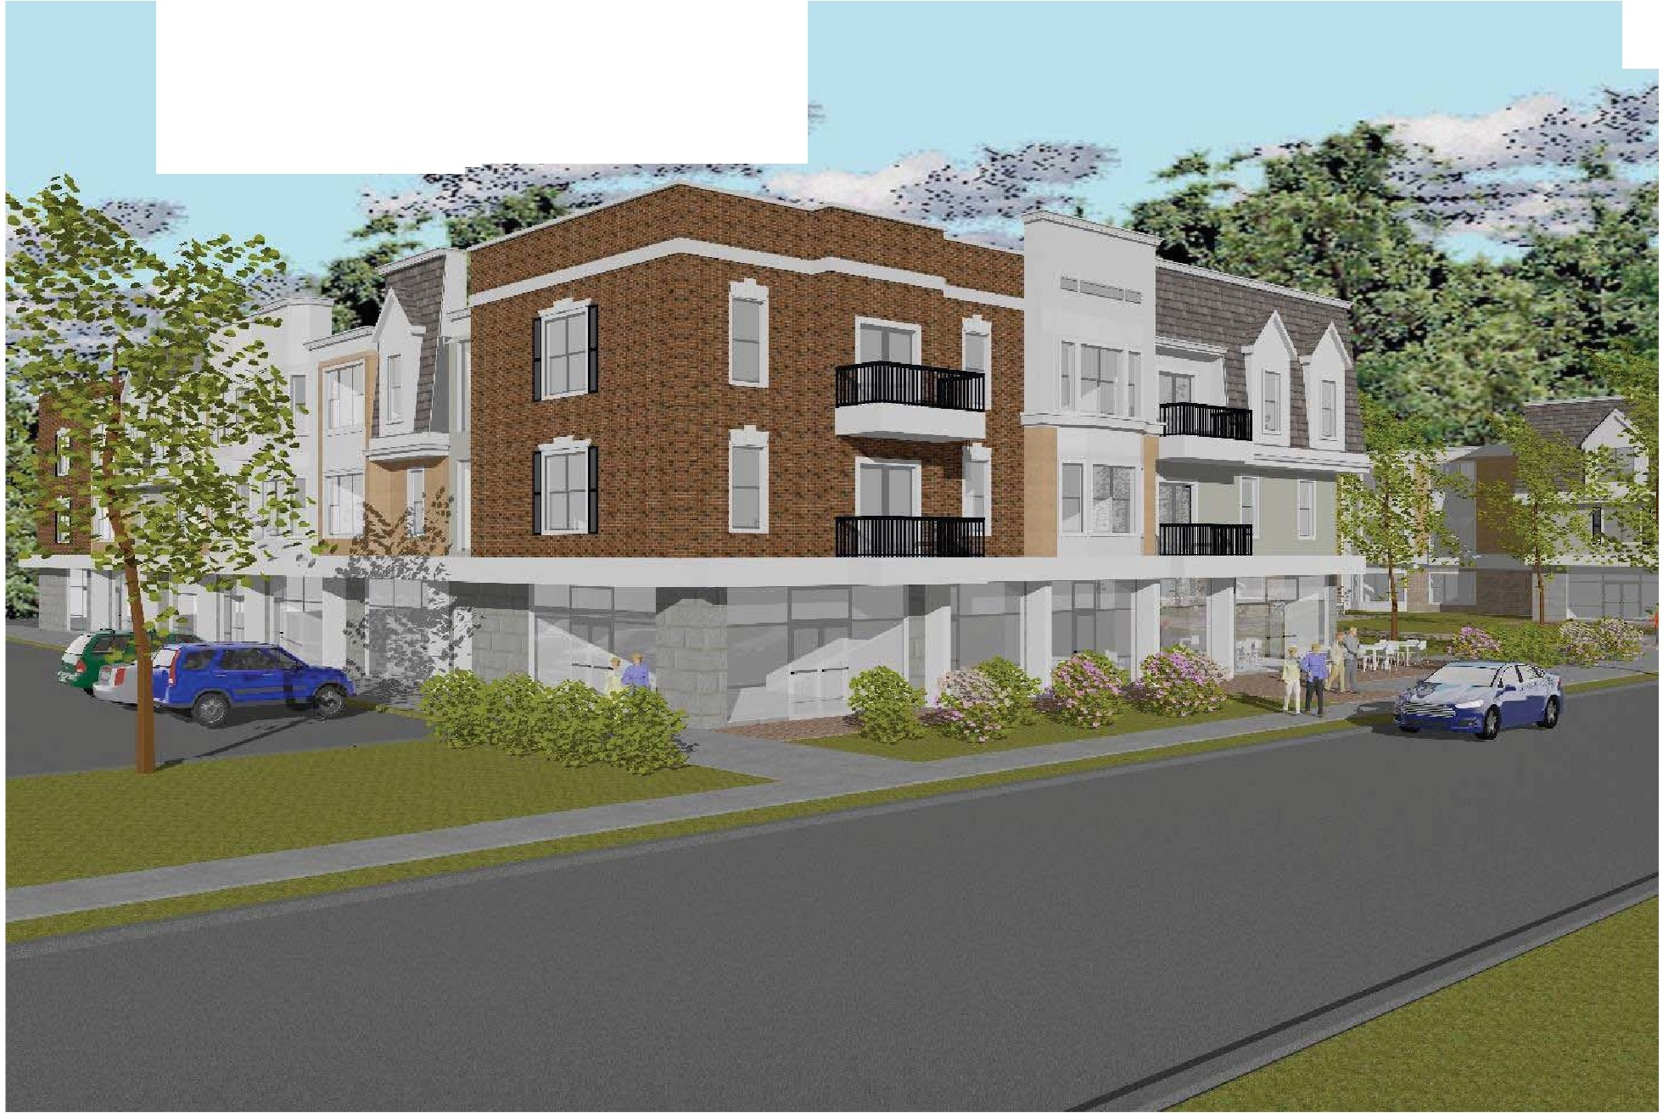
.
; --:;..:.,.-.-·
-: -c"•:··:}' t ?- ;:.
.. -

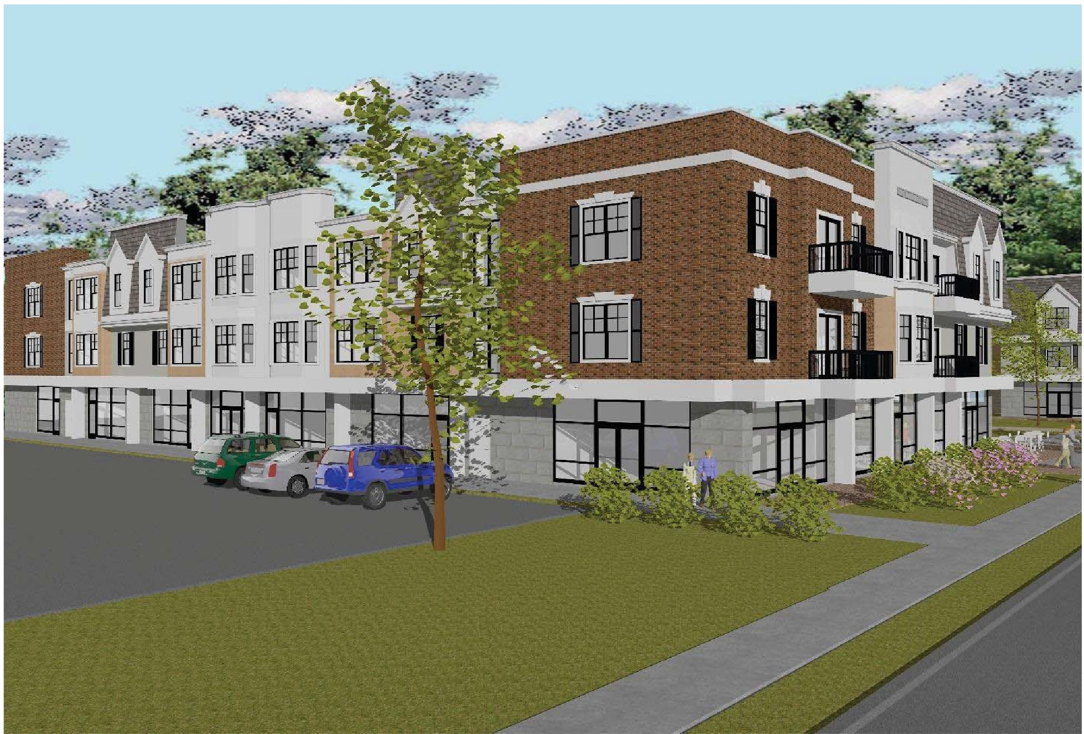

296'-0"

2 BR

COMMERCIAL 1,100 SQ. FT.
1 BR
STUDIO

STUDIO
AREA = 490 SF

AREA = 1080 SF

HWH

AREA = 740 SF

HWH

AREA = 1080 SF

HWH

HWH
2 BR

AREA = 1080 SF

HWH

AREA = 740 SF

HWH

AREA = 1080 SF
2 BR
AREA = 490 SF

HWH

AREA = 1080 SF
2 BR
1 BR
2 BR

C O R R I D O R

COMMERCIAL 1,300 SQ. FT.
HWH

UTILITY/ STORAGE

ELEV. LOBBY

B

D

D

BUSINESS OFFICE 610 SQ. FT.
C O R R I D O R

1 BEDROOM MODEL

AREA = 740 SF

HWH
HWH

STUDIO MODEL

AREA = 490 SF

2 BR
AREA = 1080 SF

HWH

HWH

2 BR
AREA = 1080 SF

HWH

1 BR
AREA = 740 SF

1 BR
AREA = 740 SF

HWH

STUDIO

AREA = 590 SF
C O R R I D O R

UTILITY/ STORAGE

ELEV. LOBBY

AREA = 740 SF
1 BR

STUDIO
AREA = 590 SF

LOBBY
HWH
HWH

160'-0" CLEAR WIDTH
79'-8" CLEAR WIDTH

STUDIO

AREA = 490 SF

LOBBY

COMMERCIAL 1,300 SQ. FT.

L O B B Y

FITNESS AREA

TENANT CONFERENCE ROOM

COFFEE/ RESTAURANT 1,900 SQ. FT.

88'-2"

20'-10"
HWH
30'-0"

C O U R T Y A R D

F A C E S S U T T O N P L A C E

20'-10"

STUDIO

AREA = 490 SF
82'-0"
HWH

STUDIO

AREA = 490 SF
HWH
HWH
STUDIO
AREA = 490 SF

TSC CORPORATE OFFICES (NORTH) 1,900 SQ.FT.

88'-2"

PROJECT DATA

STUDIO

AREA = 590 SF
HWH

1 BR
AREA = 740 SF

L O B B Y
This Drawing is an Instrument of the
or re-use of this document without the

DO NOT SCALE DRAWINGS

F I R S T F L O O R P L A N
N SCALE: 3/32" = 1'-0"

TABULATIONS- FIRST FLOOR
104 DWELLING UNITS- 135 BEDROOMS
36,500 SQ. FT. COVERAGE

TABULATIONS- TOTAL PROJECT

0 2 4 6 8 10 20
GRAPHIC SCALE

STUDIO
UNIT TYPE
QUANTITY 10
PCT. OF TOTAL 42%

STUDIO
UNIT TYPE
QUANTITY 42
PCT. OF TOTAL 40% +

- BEDROOM 1 BATH 7
- BEDROOMS 2 BATHS 7
29%

29%
- BEDROOM 1 BATH 31
- BEDROOMS 2 BATHS 31
30%
30%

ALSO:
TENANT CONFERENCE ROOM 590 SQ, FT, FITNESS AREA 1,360 SQ. FT.
TOTAL COMMERCIAL (RETAIL) AREA = 7,500 SQ. FT.

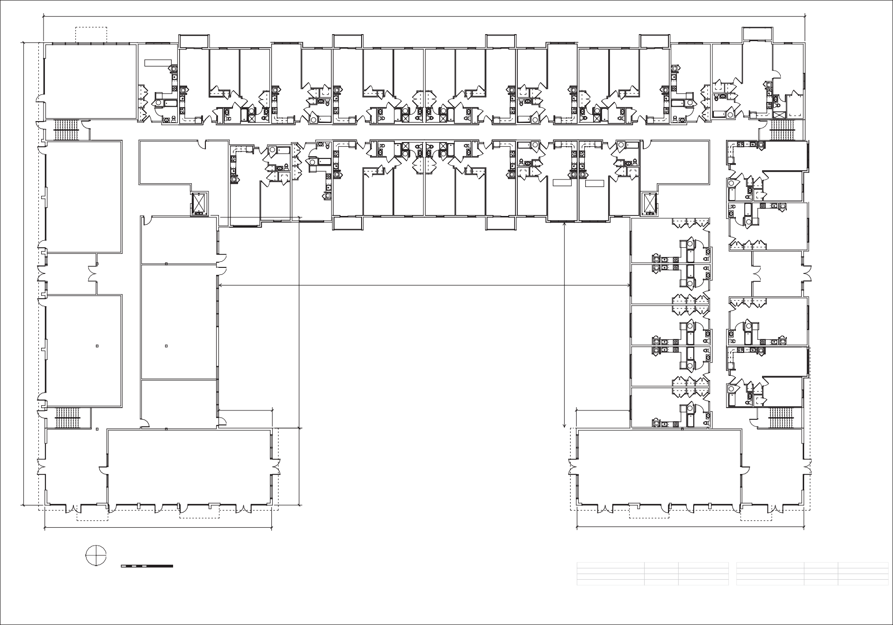
F A C E S E A S T B R O A D W A Y
180'-0"
ISSUE/ REVISIONS
DATE
DRAWING TITLE

CONCEPTUAL FIRST FLOOR PLAN
Spath Bjorklund Associates Inc. Civil/ Landscape Engineers
593 Main St., Monroe, CT 06468
(203) 268-5216
John Cruet, Jr., A. I. A. Architect
P. O. Box 435, Guilford, Ct. 06437 TEL: (203) 453-1487 FAX: (203) 458-9802
EMAIL: john.cruet@frontier.com INTERNET: www.johncruet.com
PROJECT
Stratford Centre
1000 E. Broadway, Stratford, CT Conceptual Studies for Mixed Use Development
Salce Commpanies LLC
NOTICE:
Architect's Service and, as such, remains his Property. It is supplied solely for use in conjunction with this Project. Federal Copyright law prohibits the reproduction, sale, display

express written consent of the Architect.
DATE JUNE 7 2021
SCALE AS NOTED
DRAWN JC/AIA
CHECKED
SHEET
1

296'-0"
DATE ISSUE/ REVISIONS

2 BR

AREA = 1080 SF

STUDIO

AREA = 490 SF

2 BR

AREA = 1080 SF

BR

AREA = 740 SF

2 BR

AREA = 1080 SF

2 BR

AREA = 1080 SF

1 BR

AREA = 740 SF

2 BR

AREA = 1080 SF

STUDIO

BR
AREA = 1080 SF

HWH

HWH

HWH

HWH

HWH

HWH

HWH

HWH
DRAWING TITLE
CONCEPTUAL TYPICAL FLOOR PLAN- RESIDENCES

HWH

HWH

HWH

HWH

1 BR
AREA = 740 SF

UTILITY/ STORAGE

HWH

HWH

UTILITY/ STORAGE

1 BR
AREA = 740 SF

ELEV. LOBBY
HWH

1 BR
AREA = 740 SF
BD DA

1 BR
AREA = 740 SF

2 BR

AREA = 1080 SF

2 BR

AREA = 1080 SF

1 BR
AREA = 740 SF

1 BR
AREA = 740 SF

ELEV. LOBBY
HWH
Spath Bjorklund Associates Inc. Civil/ Landscape Engineers
593 Main St., Monroe, CT 06468
(203) 268-5216

TENANT LOCKER & STORAGE TENANT LOCKER & STORAGE
HWH
HWH

1 BR

1 BR

AREA = 740 SF AREA = 740 SF

STUDIO STUDIO
HWH
HWH
HWH
HWH
John Cruet, Jr., A. I. A. Architect
P. O. Box 435, Guilford, Ct. 06437 TEL: (203) 453-1487 FAX: (203) 458-9802
EMAIL: john.cruet@frontier.com INTERNET: www.johncruet.com

STUDIO

AREA = 590 SF

AREA = 590 SF

STUDIO

AREA = 490 SF AREA = 490 SF
HWH
HWH

STUDIO

STUDIO
AREA = 490 SF

STUDIO
AREA = 490 SF

STUDIO

AREA = 490 SF AREA = 490 SF
HWH
82'-0"
HWH

STUDIO
HWH

STUDIO

1 BR
HWH

AREA = 740 SF

AREA = 490 SF

AREA = 490 SF

1 BR
PROJECT
Stratford Centre
1000 E. Broadway, Stratford, CT Conceptual Studies for Mixed Use Development
Salce Commpanies LLC
AREA = 740 SF

STUDIO STUDIO
HWH
HWH
HWH
HWH

AREA = 490 SF

20'-10"

20'-10"

AREA = 490 SF

HWH HWH
NOTICE:
This Drawing is an Instrument of the Architect's Service and, as such, remains his Property. It is supplied solely for use in conjunction with this Project. Federal Copyright law prohibits the reproduction, sale, display or re-use of this document without the express written consent of the Architect. DO NOT SCALE DRAWINGS

HWH HWH

2 BR

AREA = 1080 SF

STUDIO
AREA = 490 SF

AREA = 1080 SF

2 BR

2 BR

AREA = 1080 SF

STUDIO
30'-0"

AREA = 490 SF

2 BR

AREA = 1080 SF

88'-2"

F A C E S S U T T O N P L A C E

88'-2"

TYPICAL FLOOR PLAN- SECOND TO THIRD FLOORS
SCALE: 3/32" = 1'-0"

0 2 4 6 8 10 20
GRAPHIC SCALE

DWELLING UNIT TABULATIONS PER FLOOR

UNIT TYPE QUANTITY PCT. OF TOTAL STUDIO 16 40%
- BEDROOM 1 BATH 12 30%
- BEDROOMS 2 BATHS 12 30%

DATE JUNE 7 2021 SCALE AS NOTED DRAWN JC/AIA CHECKED
SHEET
2

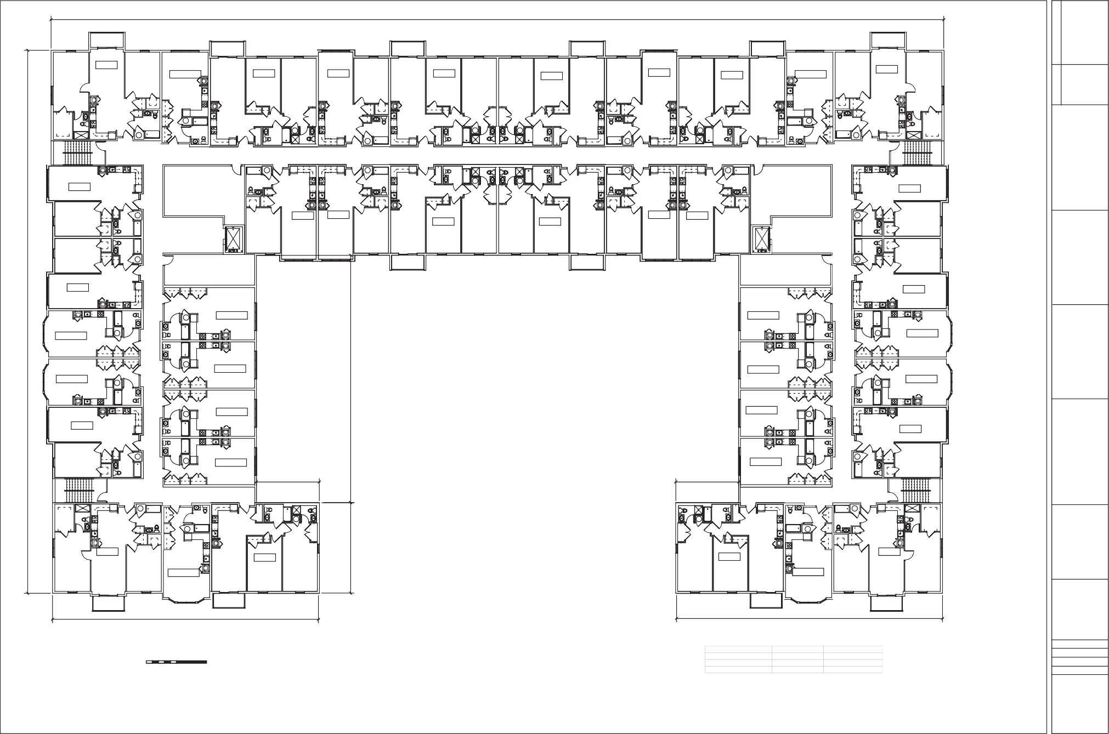
F A C E S E A S T B R O A D W A Y
180'-0"

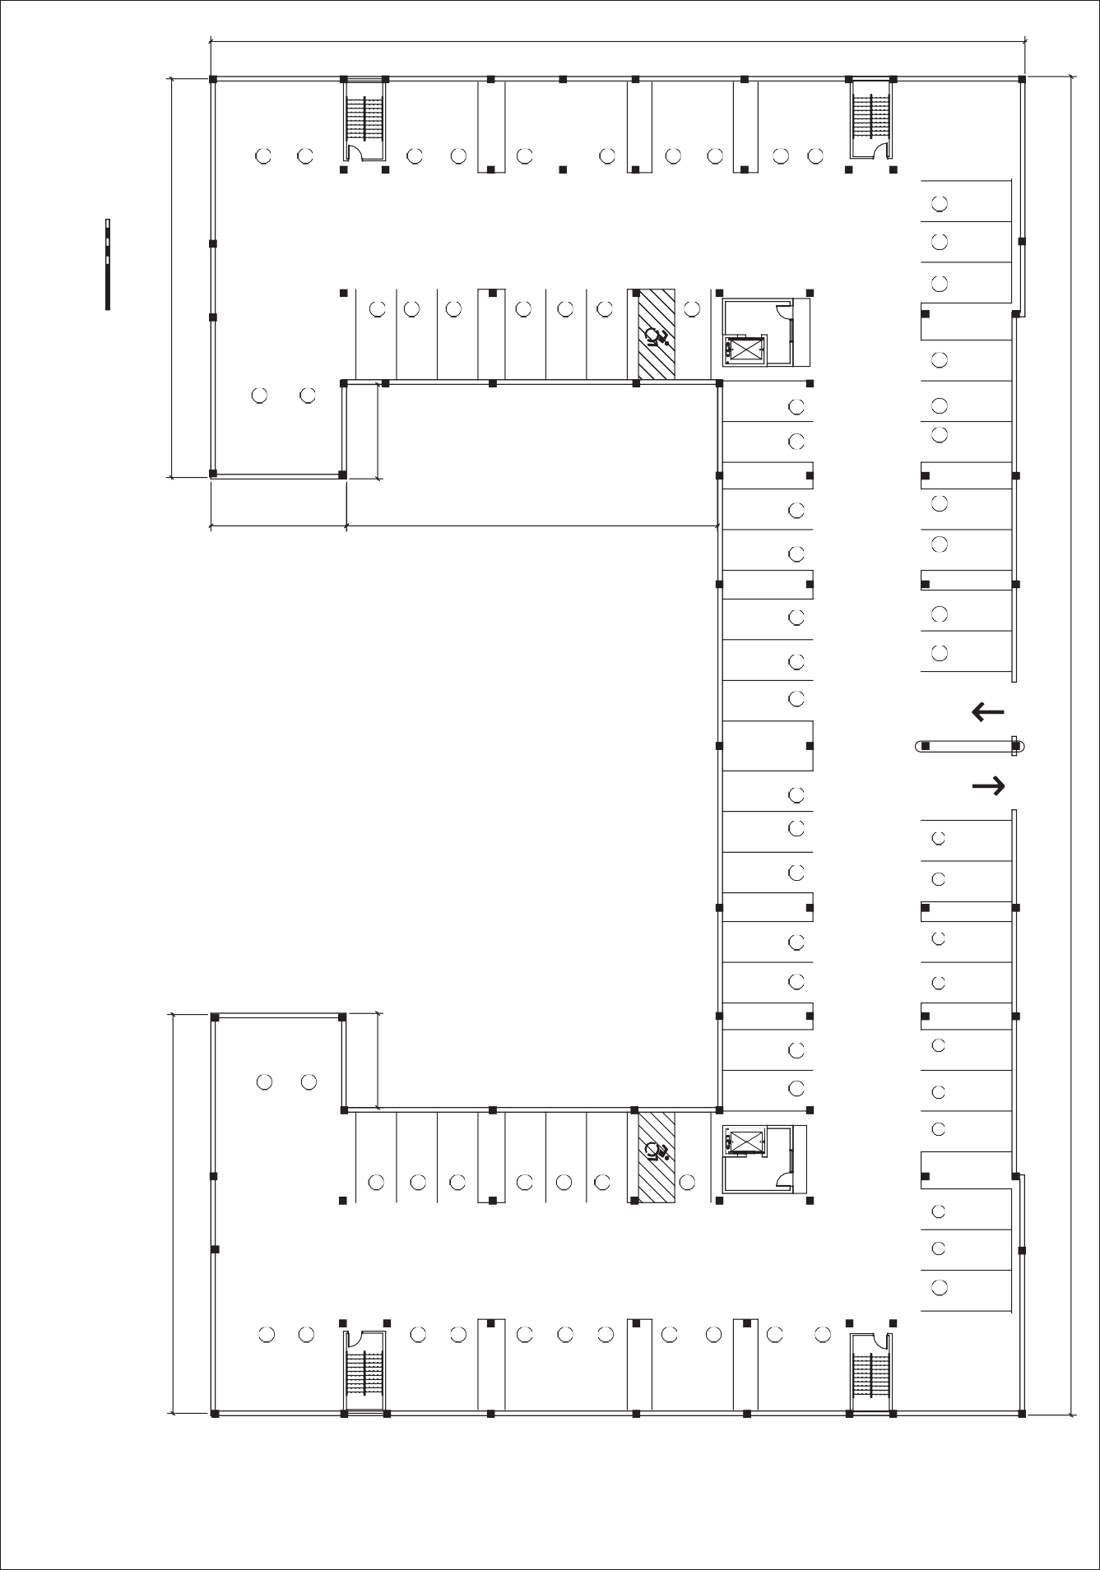
F A C E S E A S T B R O A D W A Y
EXIT
1
2
3
4
37
36
35
34
33
180'-0"

P A R K I N G
64
65
66
67
63
62
ELEV. LOBBY
ELEV.
61
VAN ACCESSIBLE SPACE
45
60
59
46
47
58
48
57
49
56
50
51
55
54
88'-2"
LOWER LEVEL PLAN- PARKING
SCALE: 3/32" = 1'-0"
0 2 4 6 8 10
GRAPHIC SCALE
20
PARKING PROVIDED FOR 73 CARS

30'-0" 82'-0"
296'-0"
ENTER
68
69
70
71
72
73
P A R K I N G
44
43
42
41
40
39
38
20'-10"
52
53
F A C E S S U T T O N P L A C E

P A R K I N G
10
5
6
7
8
9
11
32
31
12
ELEV. LOBBY
ELEV.
13
VAN ACCESSIBLE SPACE
30
14
15
29
16
28
27
17
26
18
25
19
20'-10"
24
23
20
21
22
88'-2"

SHEET  3 | CHECKED | DRAWN JC/AIA | SCALE AS NOTED | DATE JUNE 7 2021 |  | NOTICE:  This Drawing is an Instrument of the Architect's Service and, as such, remains his Property. It is supplied solely for use in conjunction with this Project. Federal Copyright law prohibits the reproduction, sale, display or re-use of this document without the express written consent of the Architect. DO NOT SCALE DRAWINGS | PROJECT  Stratford Centre  1000 E. Broadway, Stratford, CT Conceptual Studies for Mixed Use Development  Salce Commpanies LLC | John Cruet, Jr., A. I. A. Architect  P. O. Box 435, Guilford, Ct. 06437 TEL: (203) 453-1487 FAX: (203) 458-9802  EMAIL: john.cruet@frontier.com INTERNET: www.johncruet.com | Spath Bjorklund Associates Inc. Civil/ Landscape Engineers  593 Main St., Monroe, CT 06468  (203) 268-5216 | DRAWING TITLE  CONCEPTUAL LOWER LEVEL PARKING PLAN | DATE | ISSUE/ REVISIONS

ALUM. BALCONY RAIL BLACK FINISH

METAL MASONRY CAP

FACE BRICK PARAPET ARCH. PRECAST TRIM

FINISHED WOOD SHUTTERS
ARCH. PRECAST KEYSTONE

3RD FL.

FACE BRICK WITH QUOIN CORNER

2ND FL.
ALUM. FACED CANOPY
ALUM. GLAZED STOREFRONT
SIMULATED LIMESTONE
1ST FL.

SYNTHETIC STUCCO SMOOTHFINISH

FORMED METAL TRIM MANSARD SHINGLES
HARDIE PANEL W/ HARDIE TRIM

SYNTHETIC STUCCO COARSE TEXTURE

SYNTHETIC STUCCO SMOOTHFINISH

STONE VENEER

E A S T E L E V A T I O N - F A C E S S U T T O N P L A C E
SCALE: 3/32" = 1'-0"

0 2 4 6 8 10 20
GRAPHIC SCALE

ELEVATION SET BACK IN COURTYARD

METAL MASONRY CAP

FACE BRICK PARAPET ARCH. PRECAST TRIM

FACE BRICK WITH QUOIN CORNER
ARCH. PRECAST KEYSTONE

FINISHED WOOD SHUTTERS

ALUM. FACED CANOPY

ALUM. GLAZED STOREFRONT
SIMULATED LIMESTONE

3RD FL.

2ND FL.

1ST FL.

FORMED METAL TRIM MANSARD SHINGLES
EMAIL: john.cruet@frontier.com
HARDIE PANEL W/ HARDIE TRIM
HARDIE RAISED PANEL TRIM

HARDIE PANEL- SMOOTH FINISH AT BAY WINDOWS

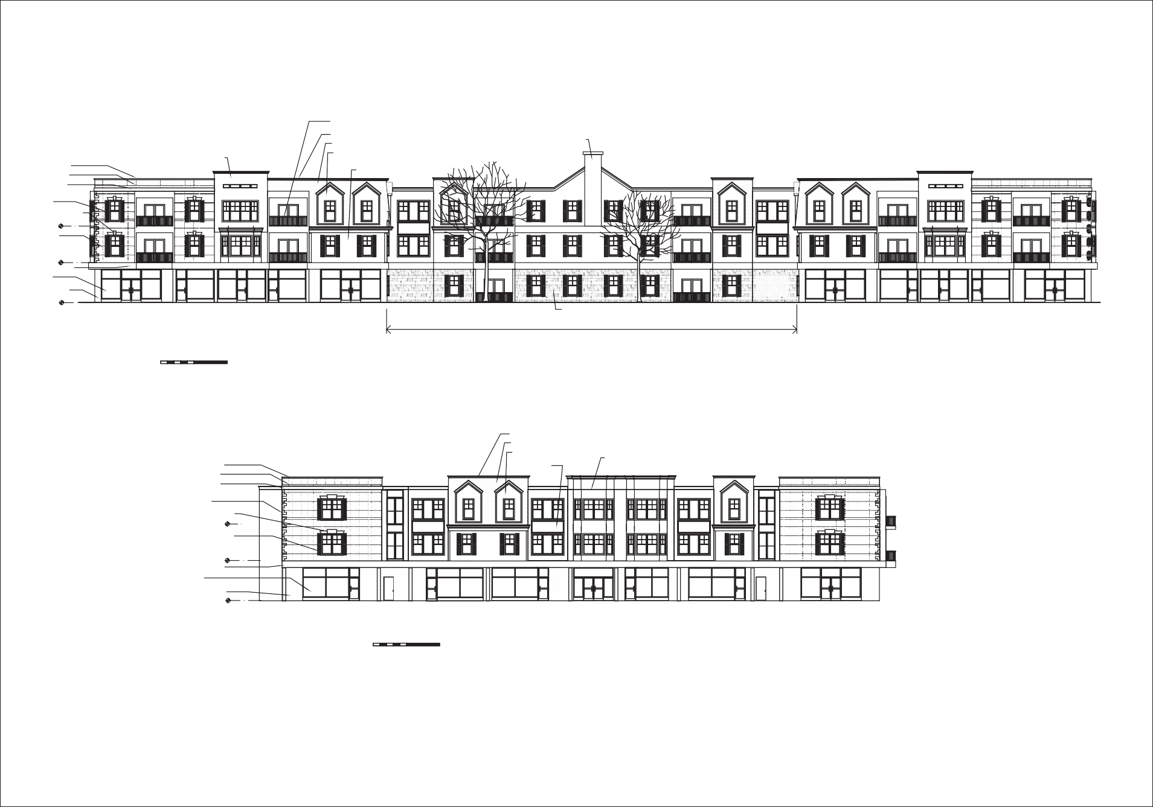
ISSUE/ REVISIONS
DATE
DRAWING TITLE
CONCEPTUAL EAST AND SOUTH ELEVATIONS
Spath Bjorklund Associates Inc. Civil/ Landscape Engineers
593 Main St., Monroe, CT 06468
(203) 268-5216
John Cruet, Jr., A. I. A. Architect
P. O. Box 435, Guilford, Ct. 06437 TEL: (203) 453-1487 FAX: (203) 458-9802

INTERNET: www.johncruet.com
PROJECT
Stratford Centre
1000 E. Broadway, Stratford, CT Conceptual Studies for Mixed Use Development
Salce Commpanies LLC
NOTICE:
Architect's Service and, as such, remains his Property. It is supplied

Project. Federal Copyright law

or re-use of this document without the express written consent of the Architect. DO NOT SCALE DRAWINGS
DATE JUNE 7 2021
SCALE AS NOTED
DRAWN JC/AIA
CHECKED
SHEET
4

S O U T H E L E V A T I O N - F A C E S E. B R O A D W A Y
This Drawing is an Instrument of the
solely for use in conjunction with this
prohibits the reproduction, sale, display
SCALE: 3/32" = 1'-0"

0 2 4 6 8 10 20
GRAPHIC SCALE

METAL MASONRY CAP FACE BRICK PARAPET
ARCH. PRECAST TRIM

FACE BRICK WITH QUOIN CORNER
ARCH. PRECAST KEYSTONE

3RD FL.

FINISHED WOOD SHUTTERS

2ND FL.

SIMULATED LIMESTONE

1ST FL.

SYNTHETIC STUCCO SMOOTH FINISH

ALUM. BALCONY RAIL BLACK FINISH
FORMED METAL TRIM MANSARD SHINGLES
HARDIE PANEL W/ HARDIE TRIM
SYNTHETIC STUCCO COARSE TEXTURE

SYNTHETIC STUCCO SMOOTH FINISH

GARAGE.

W E S T E L E V A T I O N
SCALE: 3/32" = 1'-0"

0 2 4 6 8 10 20
GRAPHIC SCALE

HARDIE RAISED PANEL W/ HARDIE TRIM

G A R A G E E N T R A N C E

HARDIE PANEL W/ HARDIE TRIM

FORMED METAL TRIM MANSARD SHINGLES
EMAIL: john.cruet@frontier.com

METAL MASONRY CAP HARDIE PANEL-
SMOOTH FINISH AT

FACE BRICK PARAPET ARCH. PRECAST TRIM

FACE BRICK WITH QUOIN CORNER

3RD FL. ARCH. PRECAST KEYSTONE FINISHED WOOD SHUTTERS

2ND FL.

ALUM. FACED CANOPY
BAY WINDOWS

1ST FL.

ALUM. GLAZED STOREFRONT

SIMULATED LIMESTONE

N O R T H E L E V A T I O N
This Drawing is an Instrument of the
solely for use in conjunction with this
prohibits the reproduction, sale, display
SCALE: 3/32" = 1'-0"

0 2 4 6 8 10 20
GRAPHIC SCALE

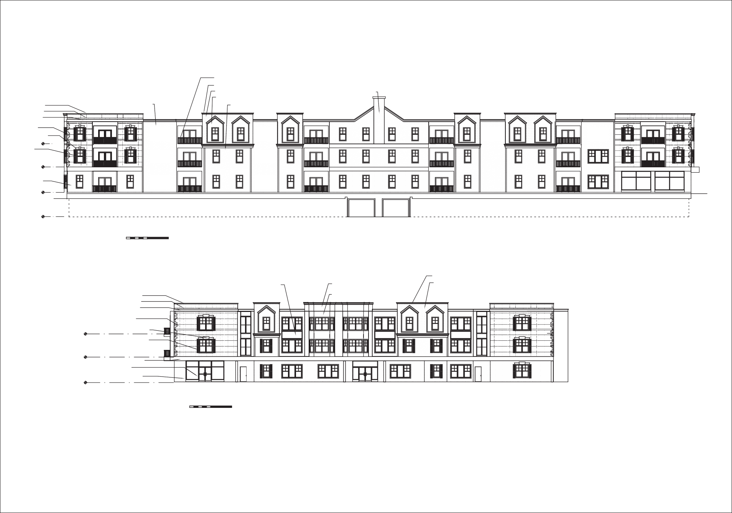
ISSUE/ REVISIONS
DATE
DRAWING TITLE
CONCEPTUAL WEST AND NORTH ELEVATIONS
Spath Bjorklund Associates Inc. Civil/ Landscape Engineers
593 Main St., Monroe, CT 06468
(203) 268-5216
John Cruet, Jr., A. I. A. Architect
P. O. Box 435, Guilford, Ct. 06437 TEL: (203) 453-1487 FAX: (203) 458-9802

INTERNET: www.johncruet.com
PROJECT
Stratford Centre
1000 E. Broadway, Stratford, CT Conceptual Studies for Mixed Use Development
Salce Commpanies LLC
NOTICE:
Architect's Service and, as such, remains his Property. It is supplied

Project. Federal Copyright law

or re-use of this document without the express written consent of the Architect. DO NOT SCALE DRAWINGS
DATE JUNE 7 2021
SCALE AS NOTED
DRAWN JC/AIA
CHECKED
SHEET
5

