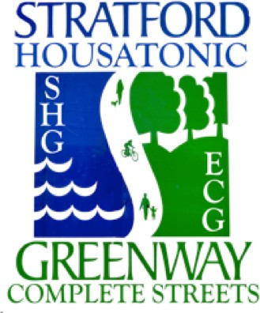
THE STRATFORD
HOUSATONIC GREENWAY/ COMPLETE STREETS COMMITTEE
Is sponsoring a
FREE & SECURE PARKING CORRAL at the MAIN STREET FESTIVAL on June 4th, 2022.

Make this your year to bike to the Main Street Festival And during your visit, use our FREE & SECURE BIKE PARKING Location: MAIN STREET AT BROAD STREET @ 10AM to 3:30PM
YOU MUST WALK YOU BIKE WITHIN THE MAIN STREET FESTIVAL AREA.
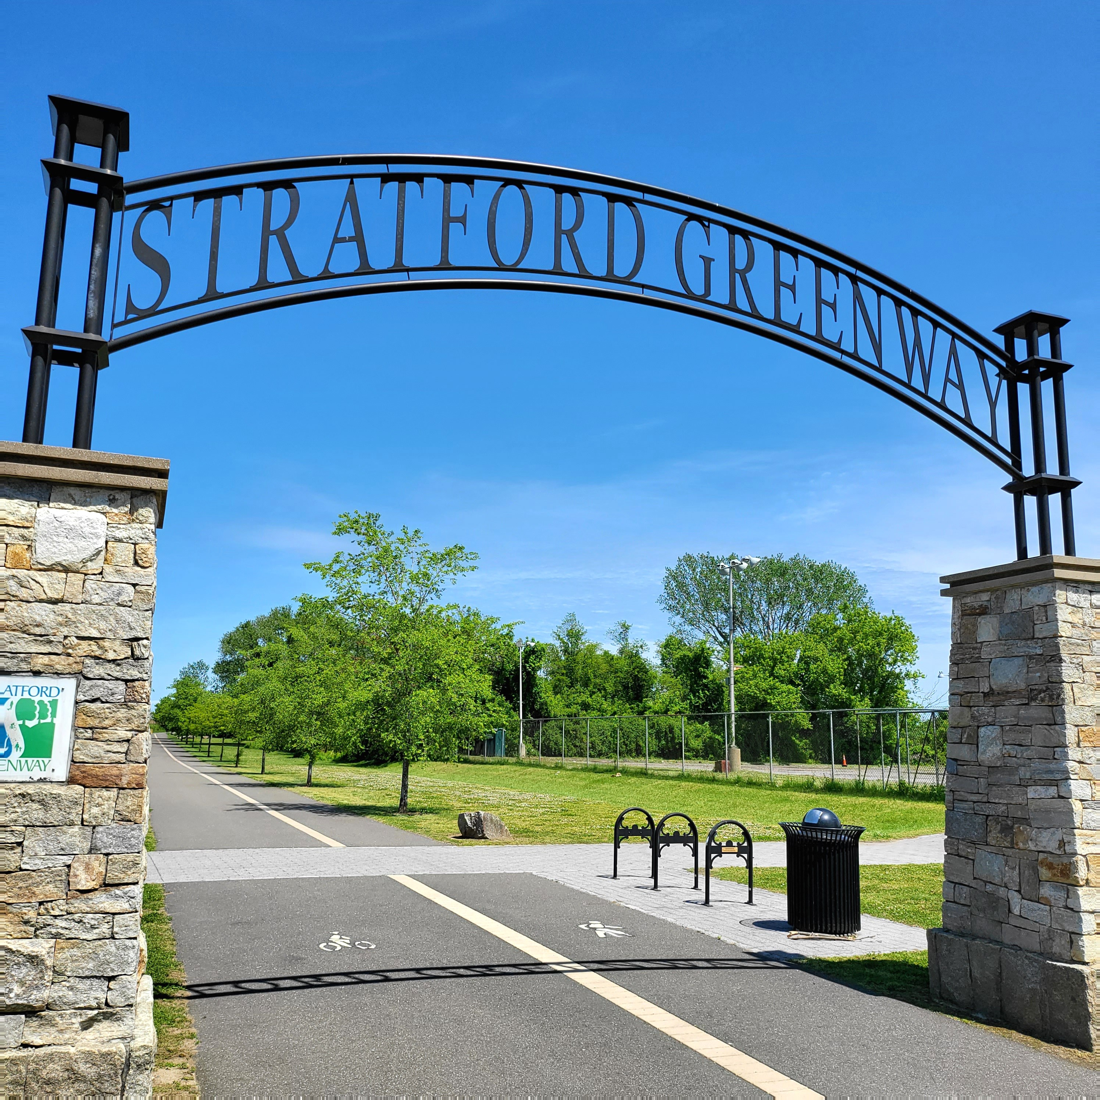
- Also, CHECK out OUR BOOTH that includes current COMPLETE STREETS maps showing the Main Street & Elm Street Extensions that will begin construction this fall.

- We will also have information FREE WALKING MAPS covering TEN Stratford neighborhoods, Likely including yours.

THEN, AT PM EVERY CYCLIST IS INVITED to the first Stratford Housatonic Greenway GROUP RIDE of the 2022 season.
We are the STRATFORD GREENWAY/COMPLETE STREETS COMMITTEE and are proud to be sponsored by Stratford RECREATION DEPARTMENT
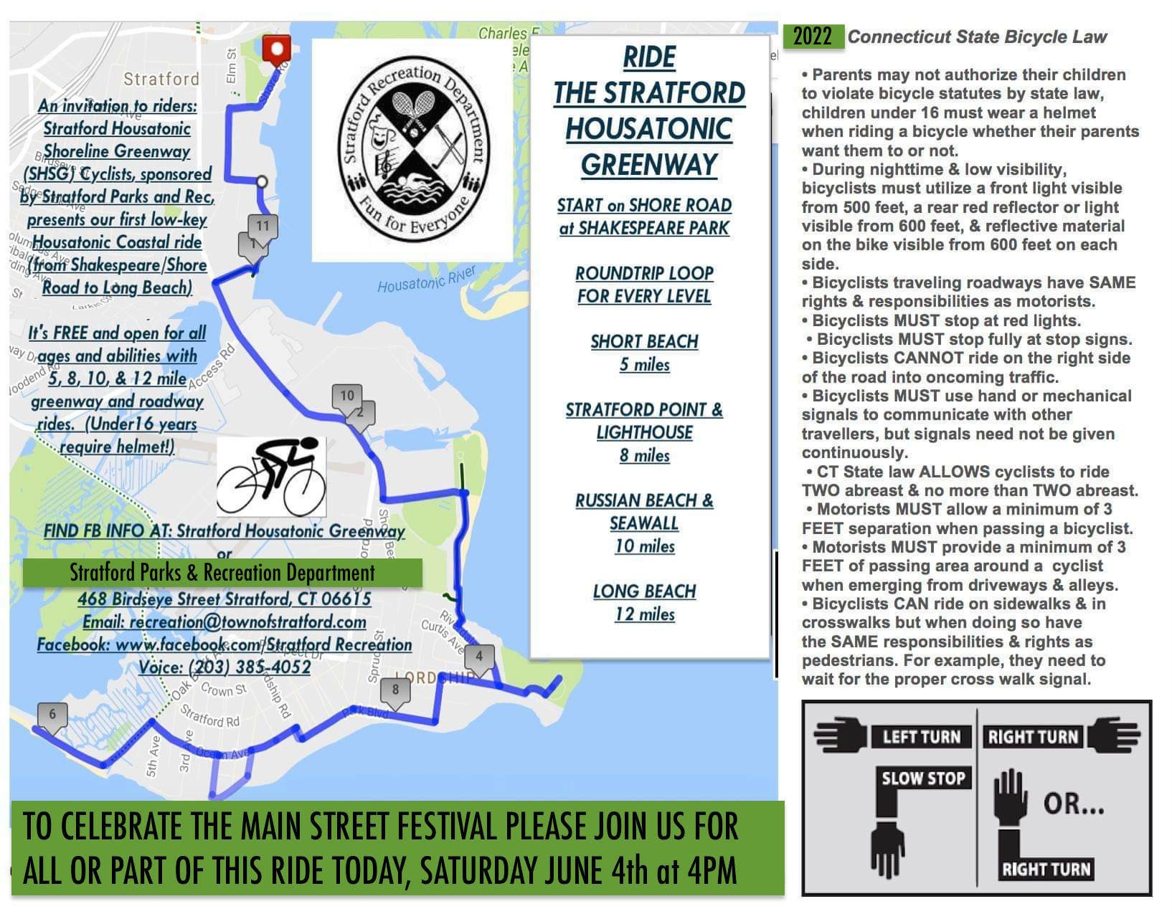
and supported by the Stratford ROTARY.

- At 4:00 PM RIDERS will assemble at the SHAKESPEARE PARK on Shore Road and depart at 4:30 PM for a ride that will journey to Short Beach, Long Beach, the Sea Wall and then return back in a mostly level loop.

- A route map is available at our booth or online at Stratford Recreation Department https://stratfordct.gov/recreation or on FB at the STRATFORD HOUSATONIC GREENWAY

- Please bring water and check your tire’s
air pressure. Helmets are required for less than 16 years, but recommended for all. You will be required to sign a waiver.

- EVERYONE IS WELCOME and don’t worry, you can choose 5, 8, 10 or 12 miles routes. The full ride should last about two hours.

